Spiral-Like Open Curves
# Source: AI Source: Provided by: [Data Path: Persons Table -> ID Column: 1, Name_En Column: Motasem Essam] -> From: [ChatGPT] on [7/25/2026]
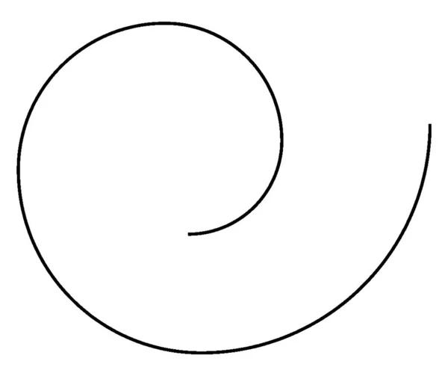
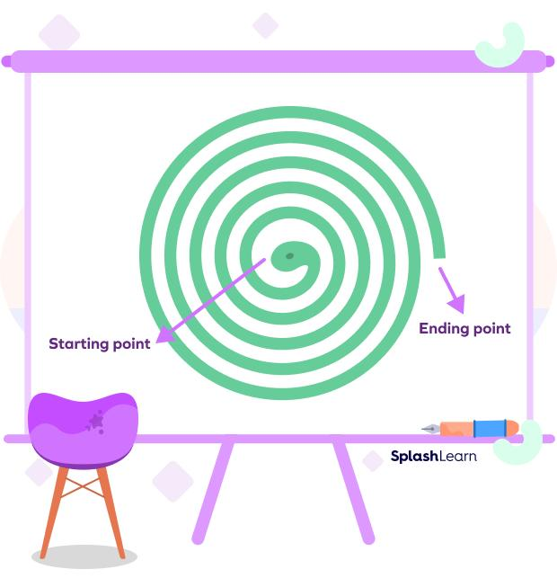
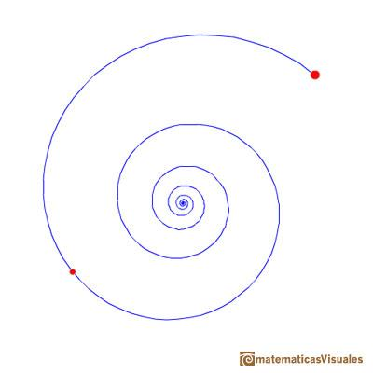
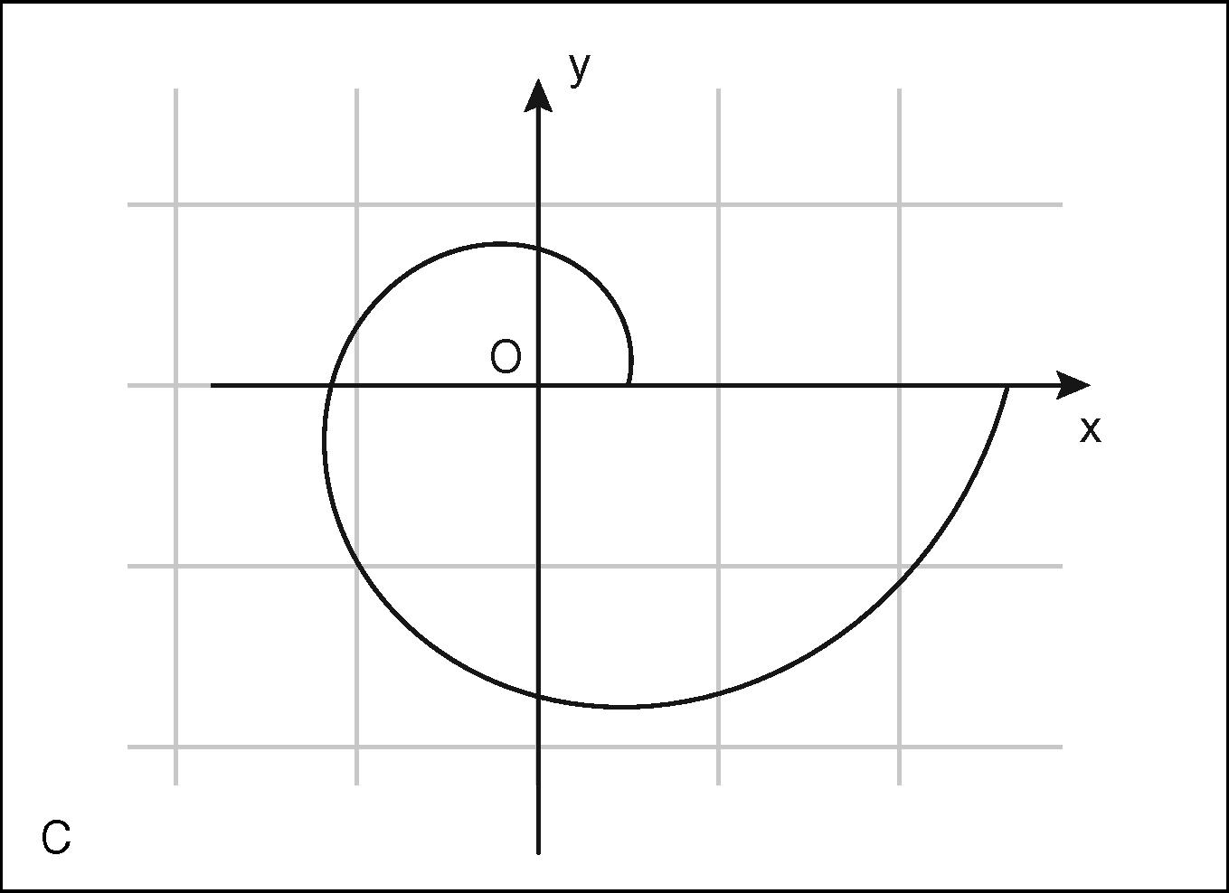
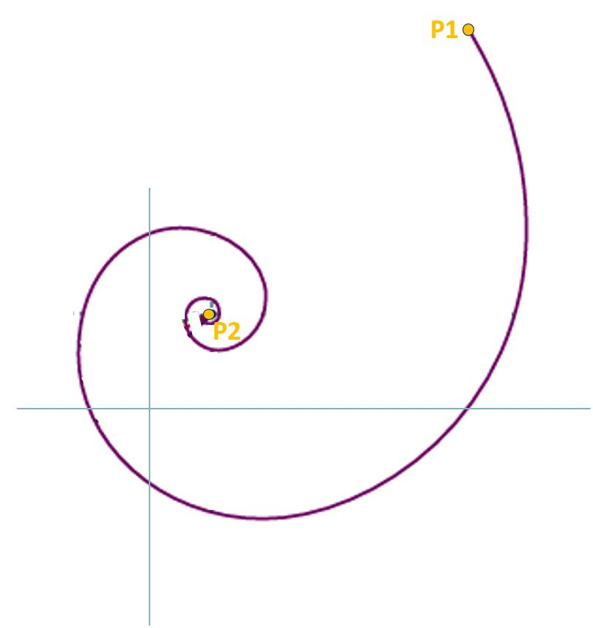

Definition
# Source: AI Source: Provided by: [Data Path: Persons Table -> ID Column: 1, Name_En Column: Motasem Essam] -> From: [ChatGPT] on [7/25/2026]
A Spiral-Like Open Curve is an open curved shape that winds around a central point, axis, or region while continuously moving away from or toward it, without closing into a complete loop.
$$\boxed{\text{Spiral-Like Open Curve}=\text{Open}+\text{Curved}+\text{Winding}+\text{Ch}\text{anging}\text{ Distance from Center}}$$
Unlike a circle, a spiral-like curve does not maintain a constant distance from its center.

Characteristics
# Source: AI Source: Provided by: [Data Path: Persons Table -> ID Column: 1, Name_En Column: Motasem Essam] -> From: [ChatGPT] on [7/25/2026]
A Spiral-Like Open Curve:
- Is open.
- Has two endpoints.
- Winds around a center or central region.
- Usually changes its distance from the center.
- Does not enclose a region by itself.
- May move outward or inward.
- May have regular or irregular spacing.
- May be smooth or irregular.
- Can rotate through multiple turns.
- Can be symmetric or asymmetric.

Types of Spiral-Like Open Curves

1. Archimedean Spiral-Like Open Curve
# Source: AI Source: Provided by: [Data Path: Persons Table -> ID Column: 1, Name_En Column: Motasem Essam] -> From: [ChatGPT] on [7/25/2026]
An Archimedean spiral has approximately equal spacing between successive turns.
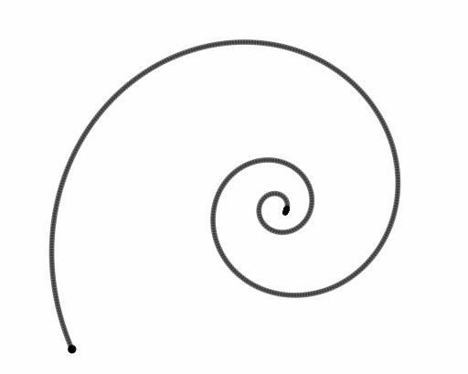
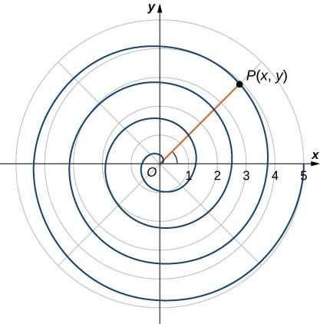
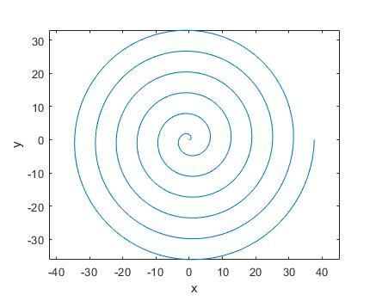
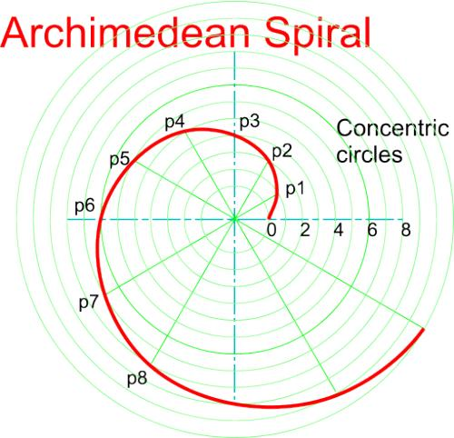
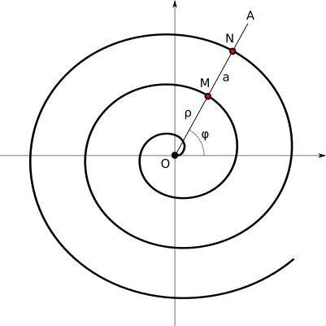
A common mathematical representation is:
$$\boxed{r=a+bθ}$$
The radial distance changes approximately linearly with the angle.

2. Logarithmic Spiral-Like Open Curve
# Source: AI Source: Provided by: [Data Path: Persons Table -> ID Column: 1, Name_En Column: Motasem Essam] -> From: [ChatGPT] on [7/25/2026]
A logarithmic spiral changes its distance from the center exponentially as it rotates.
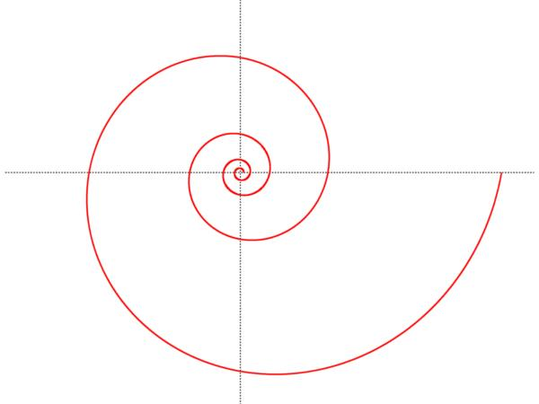
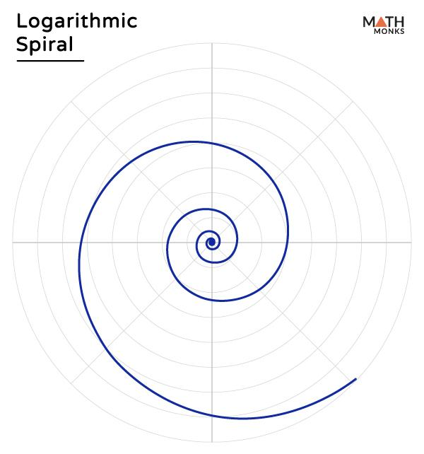
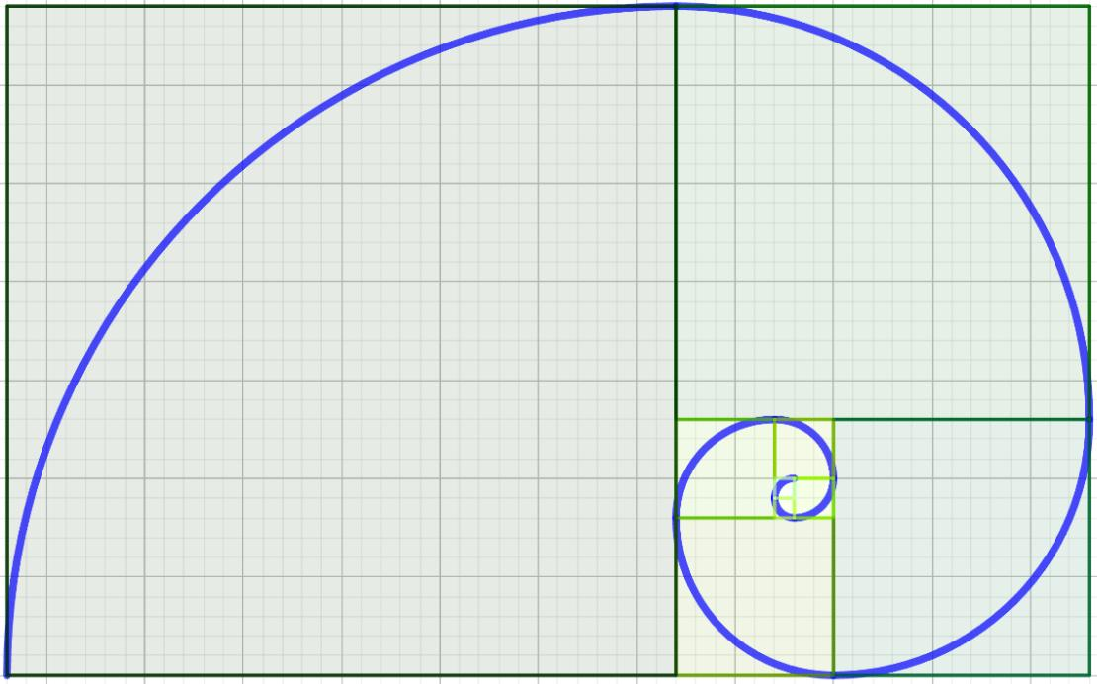
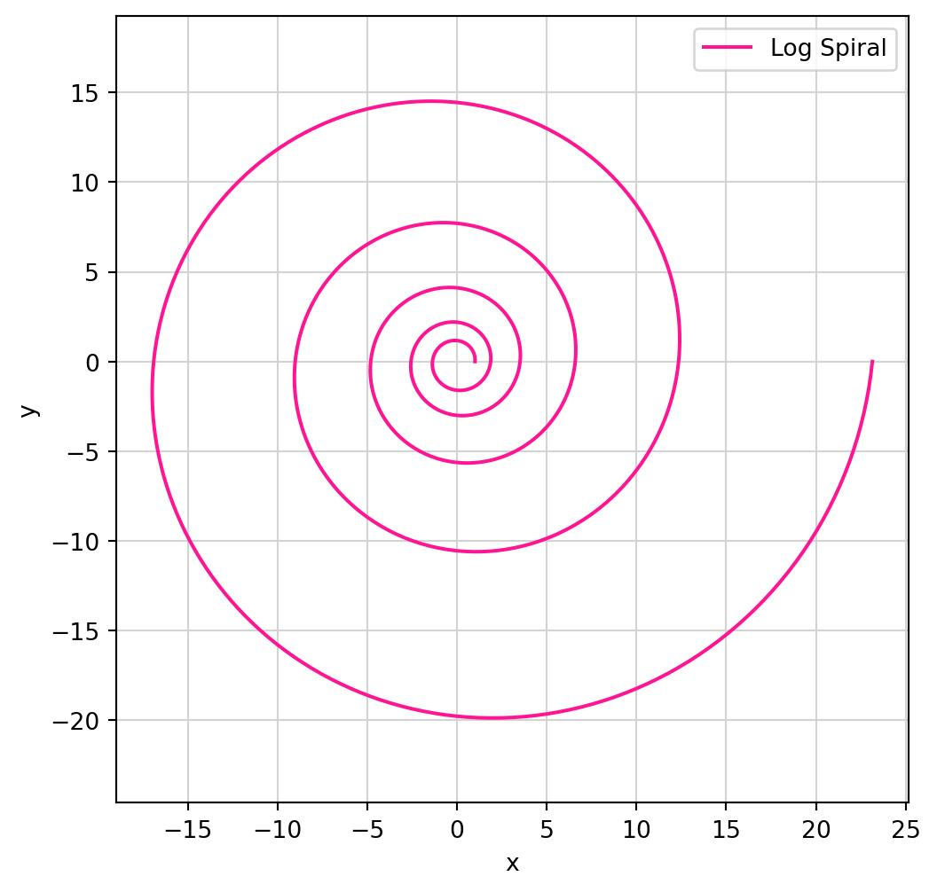
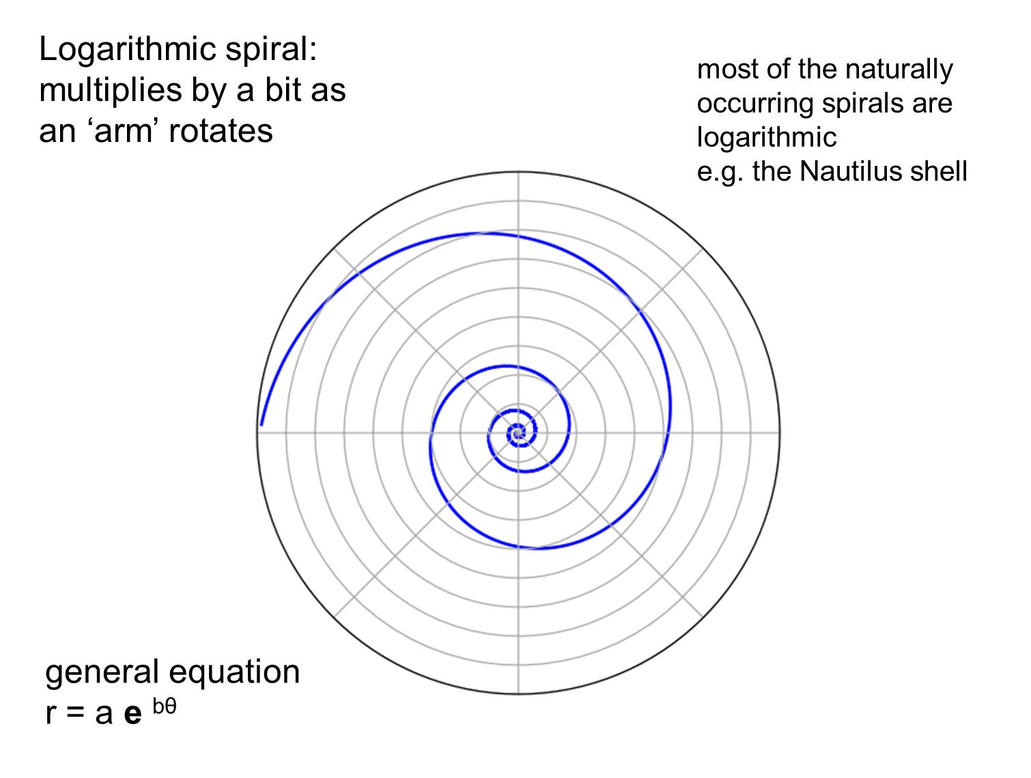
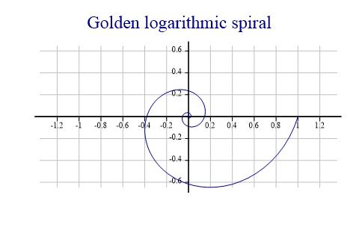
A common representation is:
$$\boxed{r=ae^{bθ}}$$
This produces a spiral whose shape remains similar as it expands.

3. Inward Spiral-Like Open Curve
# Source: AI Source: Provided by: [Data Path: Persons Table -> ID Column: 1, Name_En Column: Motasem Essam] -> From: [ChatGPT] on [7/25/2026]
The curve winds toward a central point.
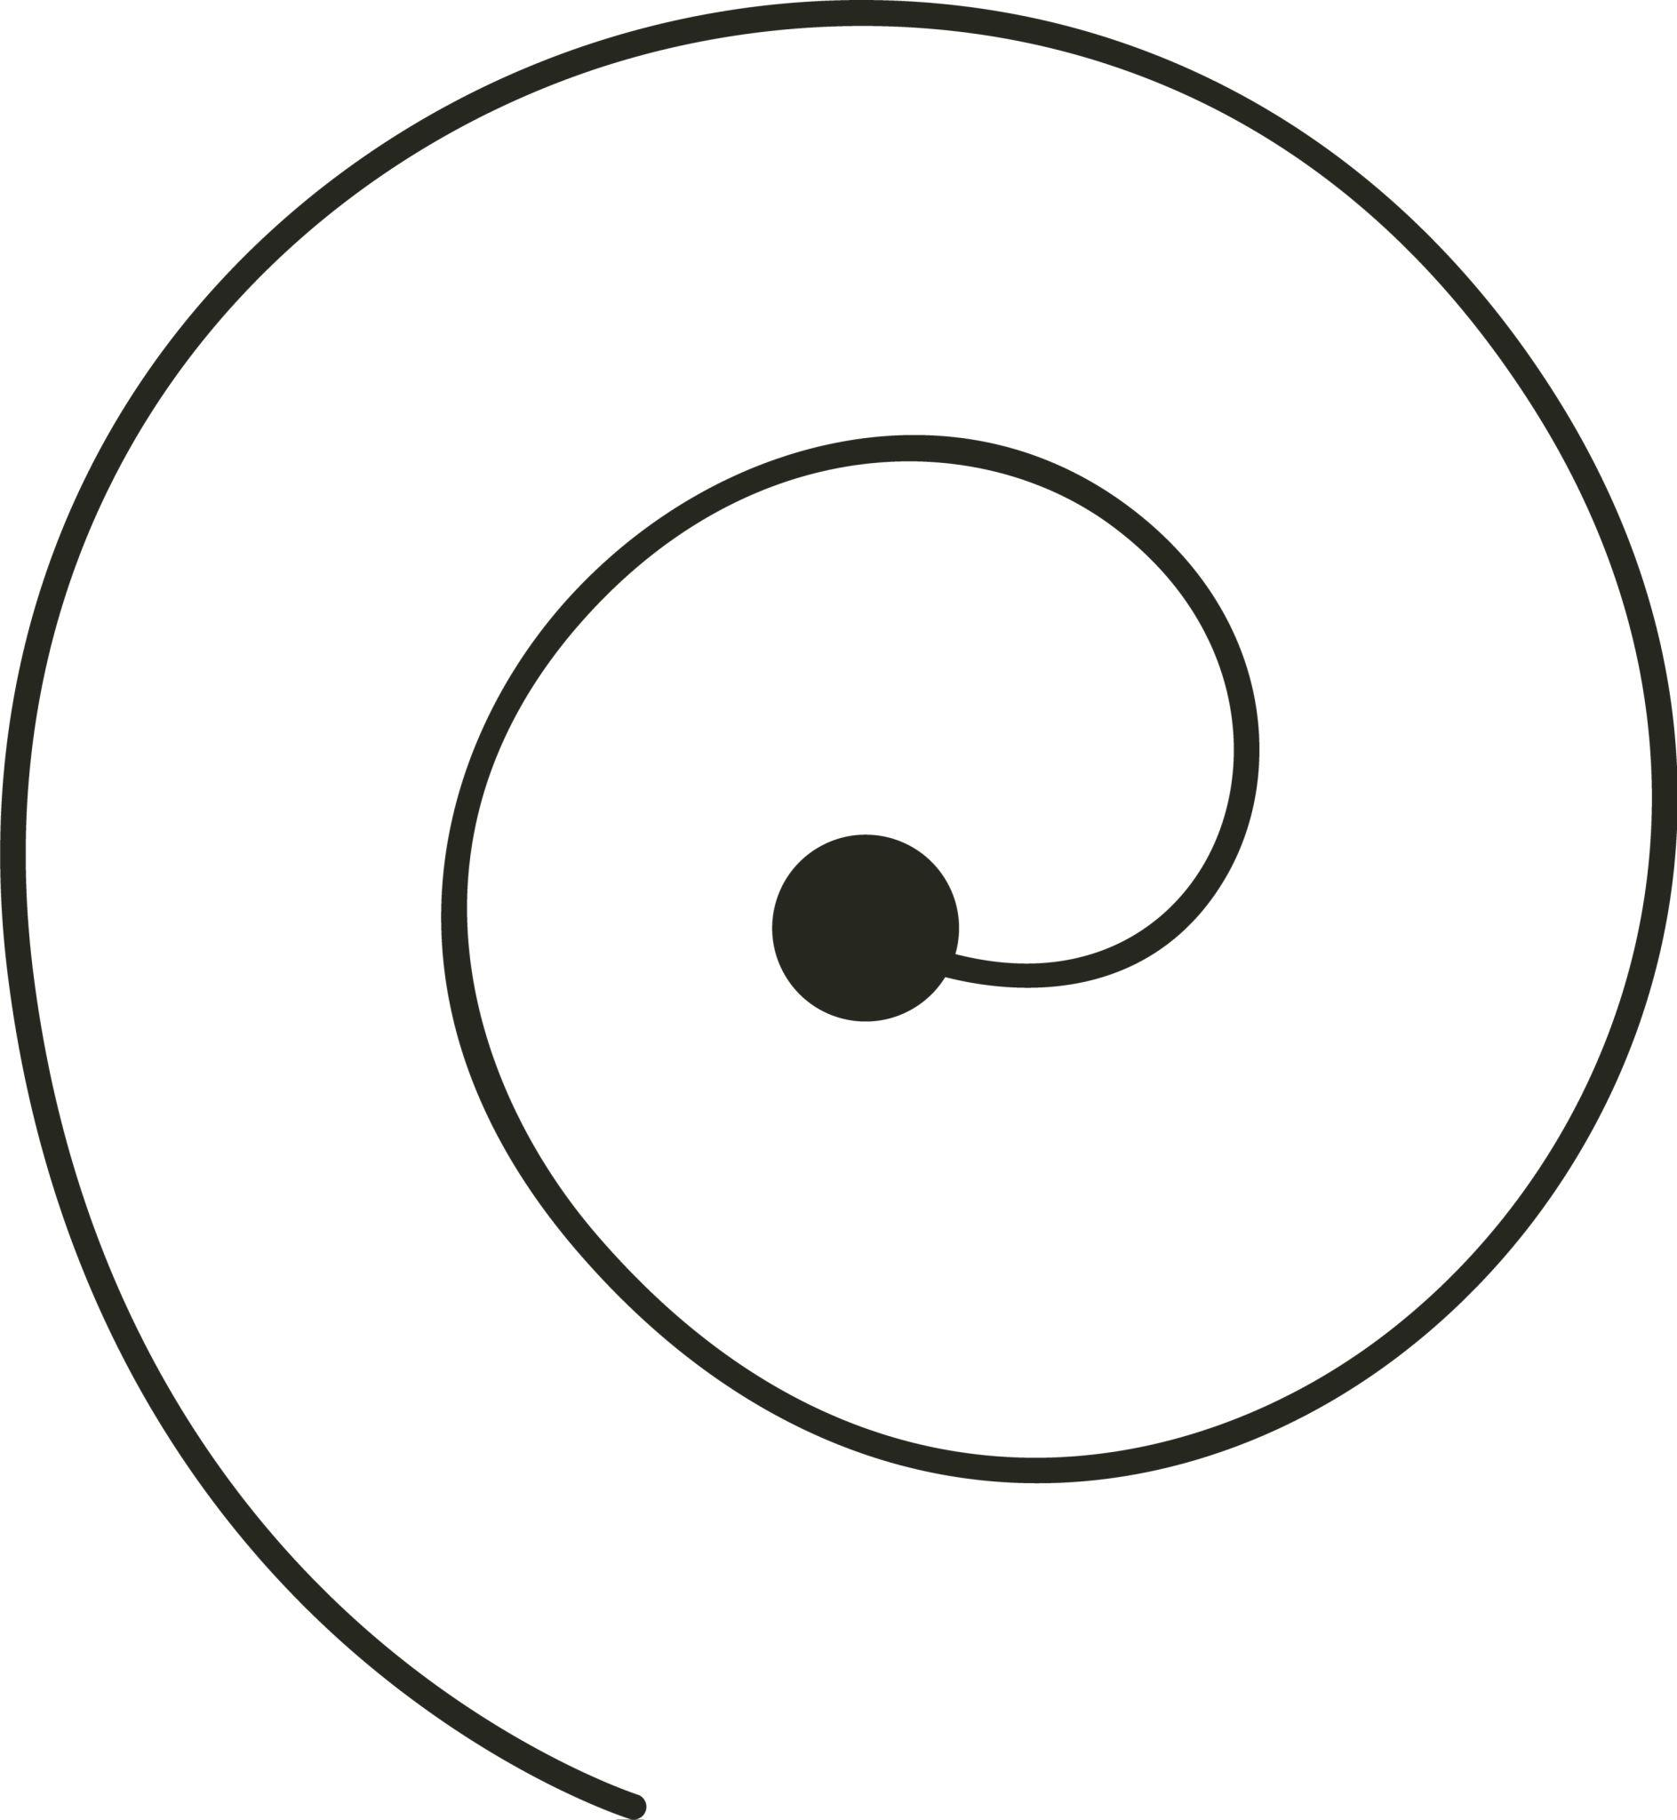
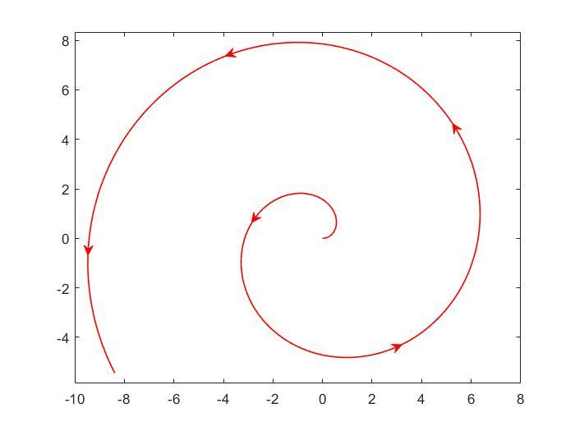
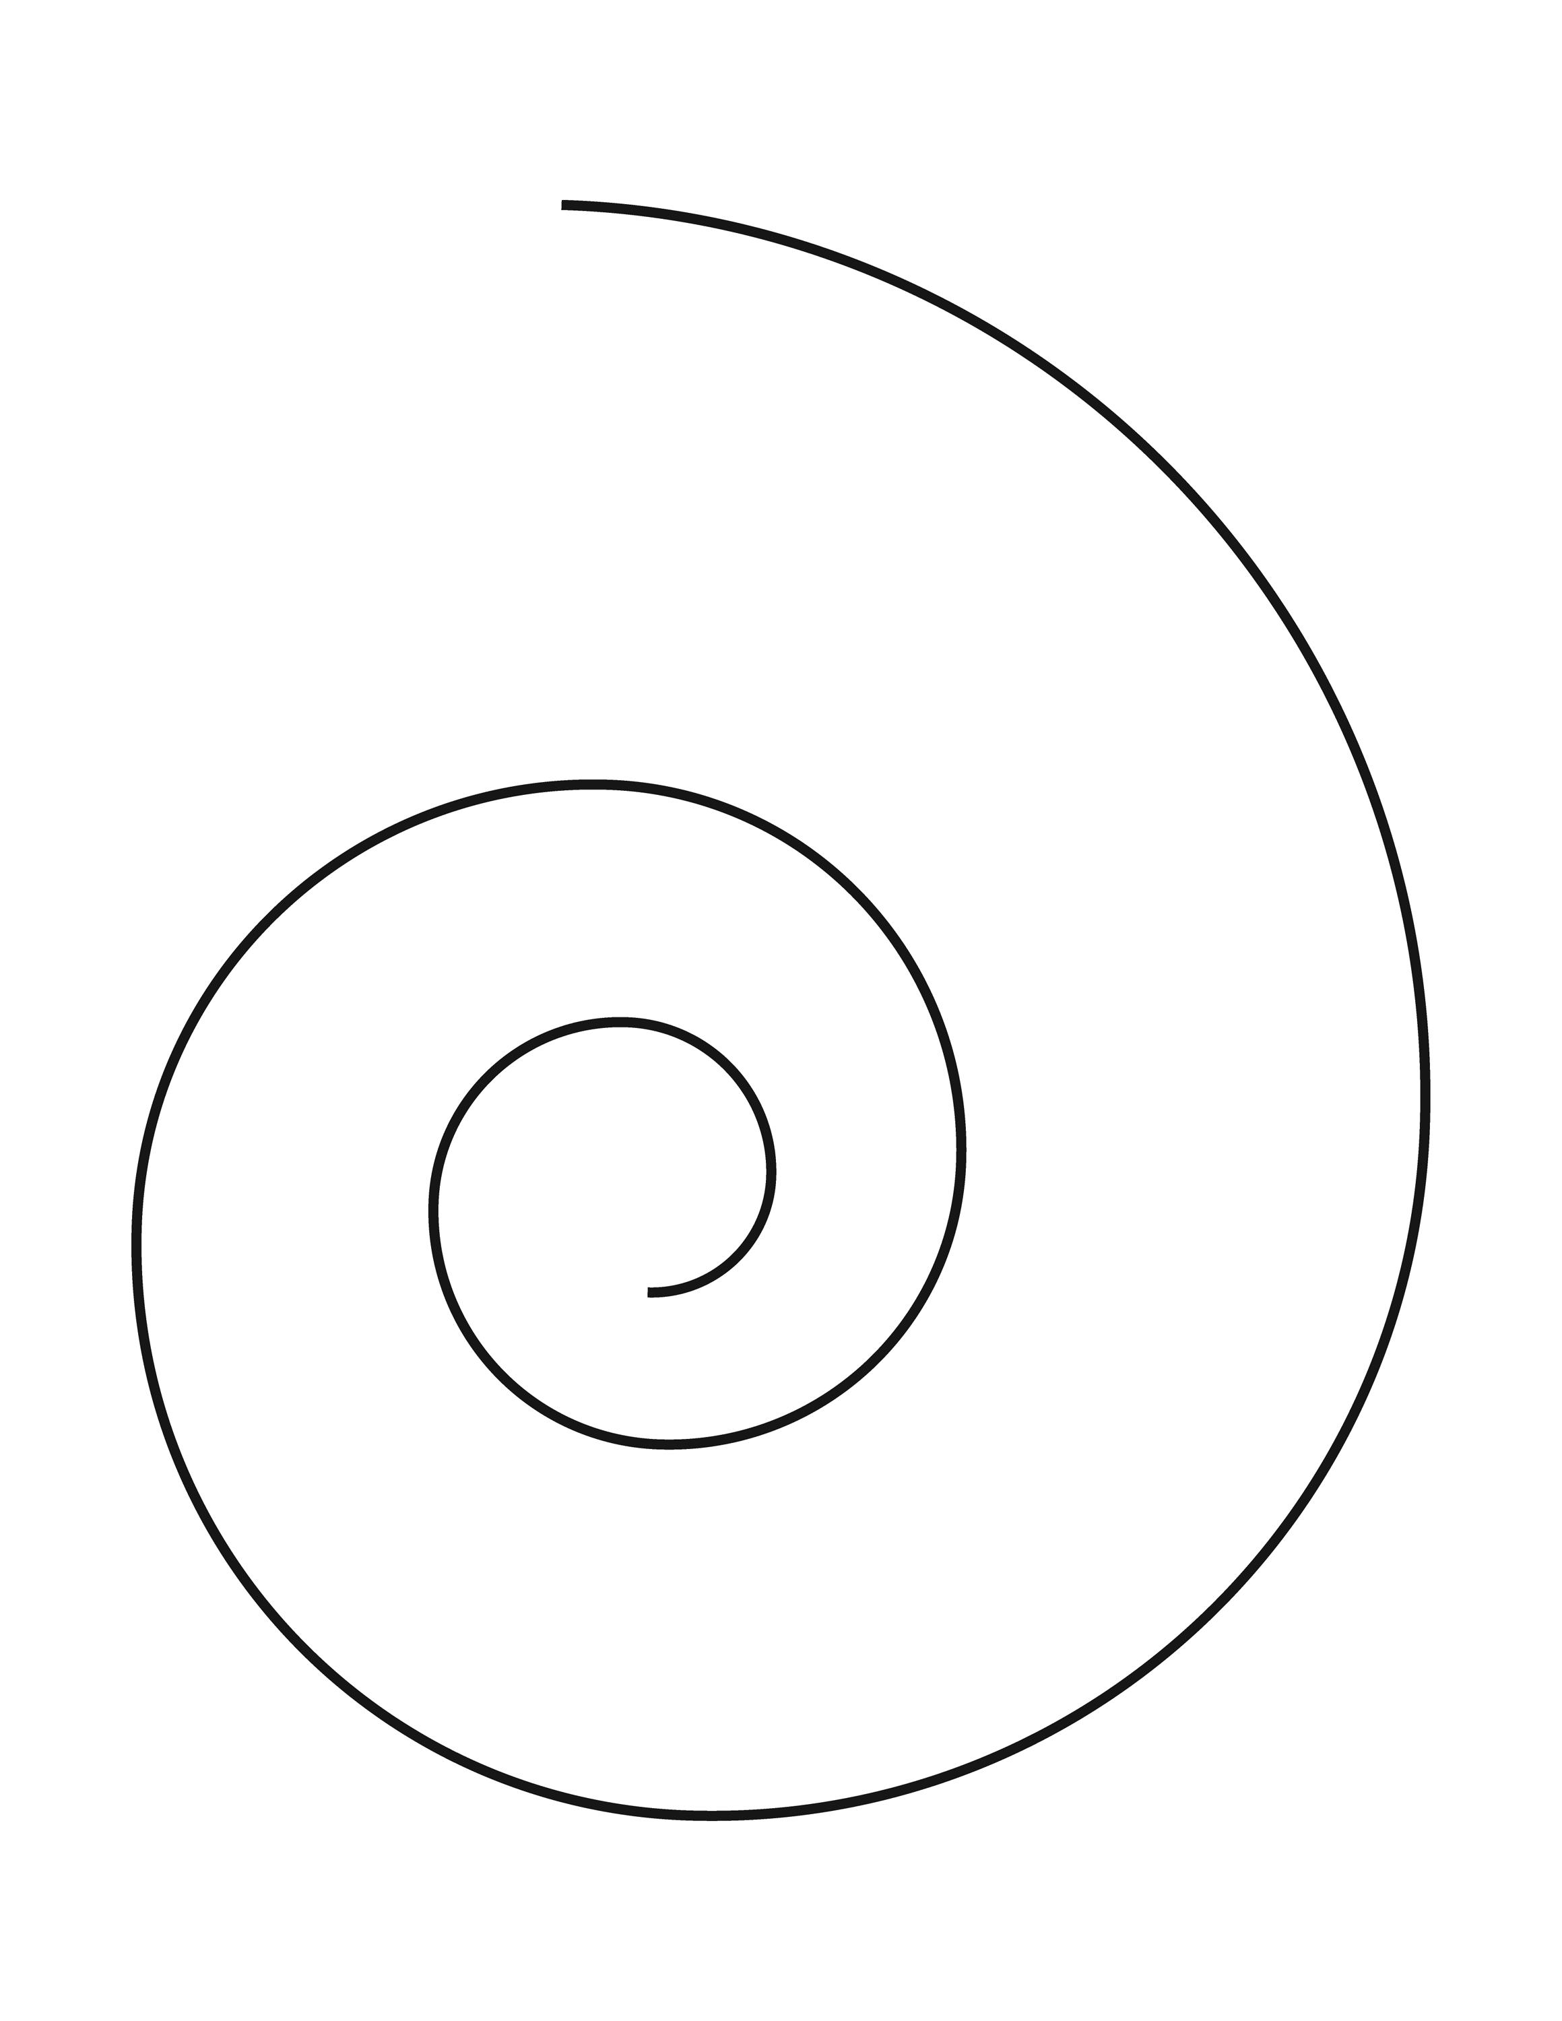
The distance from the center generally decreases along the curve.

4. Outward Spiral-Like Open Curve
# Source: AI Source: Provided by: [Data Path: Persons Table -> ID Column: 1, Name_En Column: Motasem Essam] -> From: [ChatGPT] on [7/25/2026]
The curve winds outward from a central region.
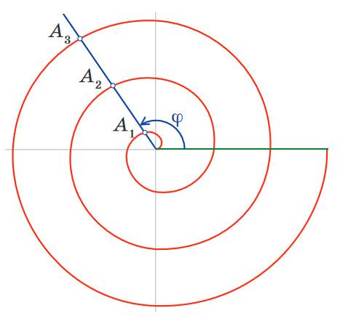
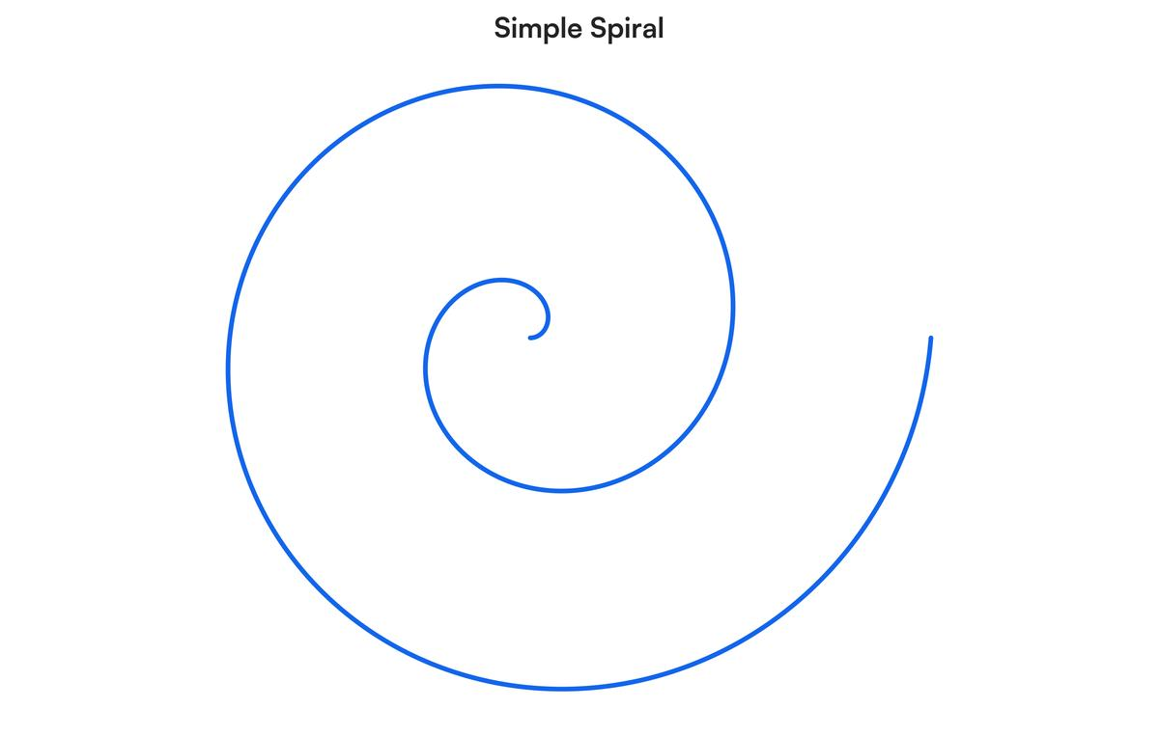
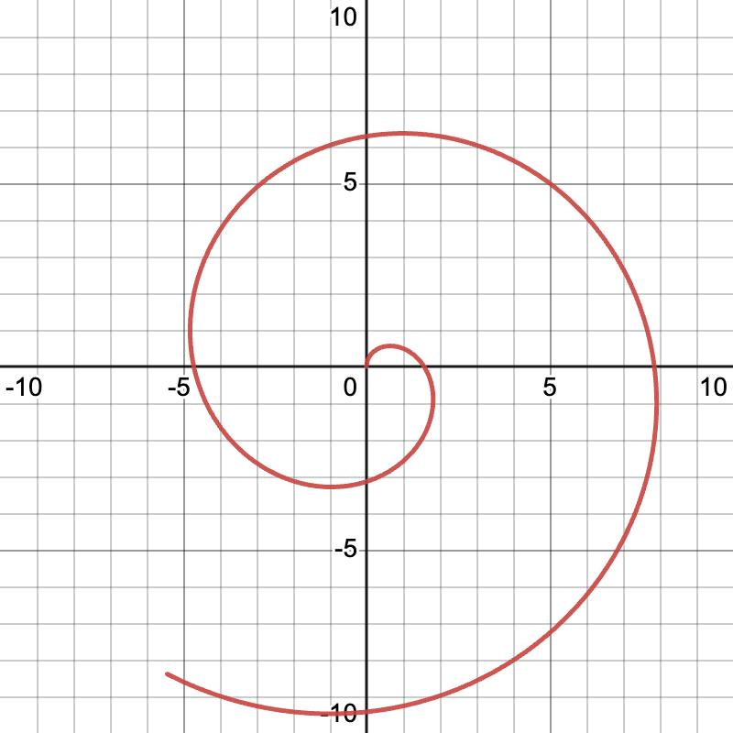
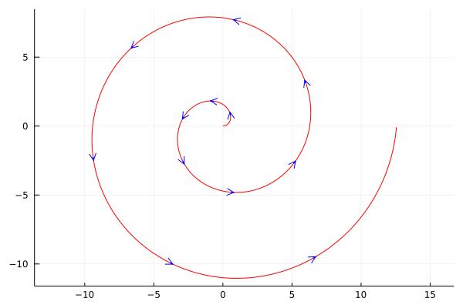
The distance from the center generally increases.

5. Tight Spiral-Like Open Curve
# Source: AI Source: Provided by: [Data Path: Persons Table -> ID Column: 1, Name_En Column: Motasem Essam] -> From: [ChatGPT] on [7/25/2026]
The turns are closely spaced.
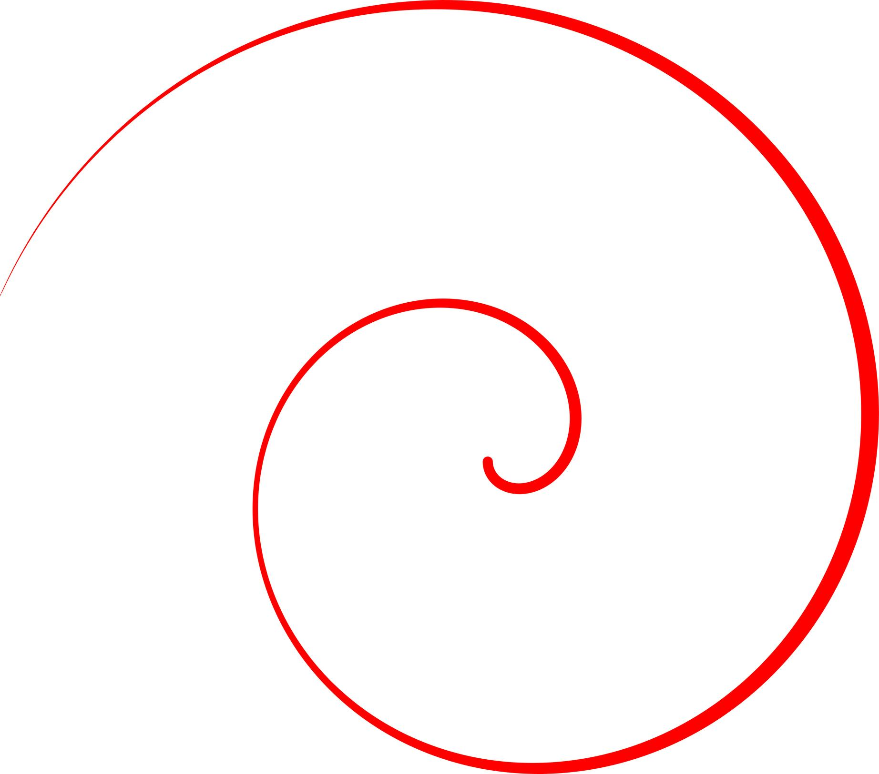
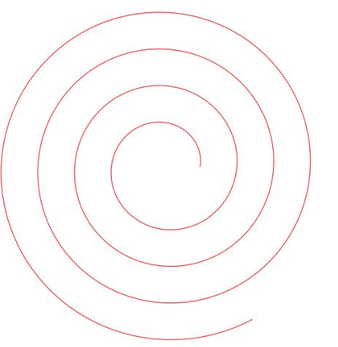
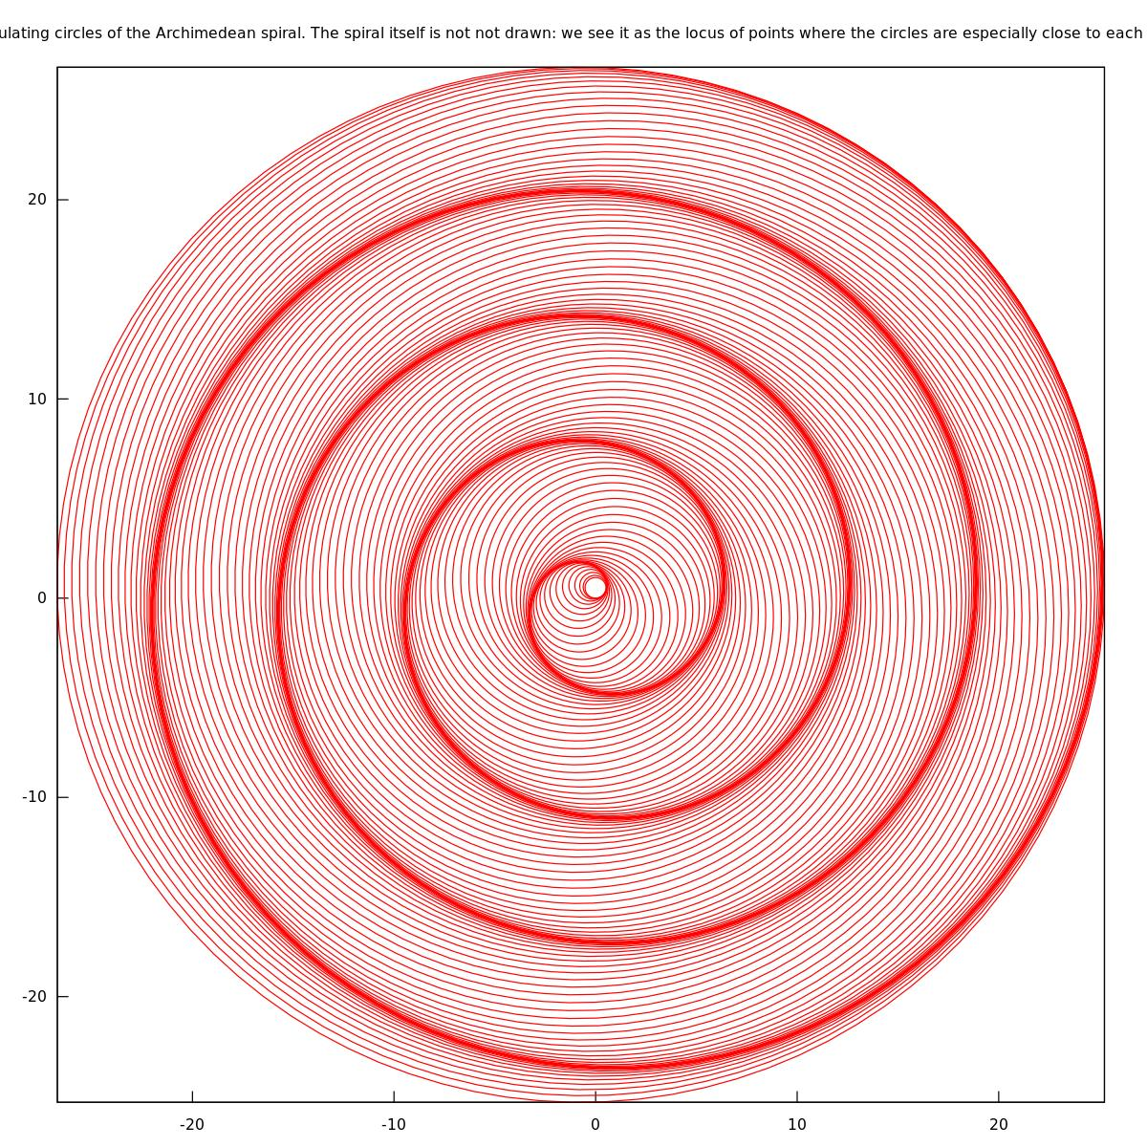
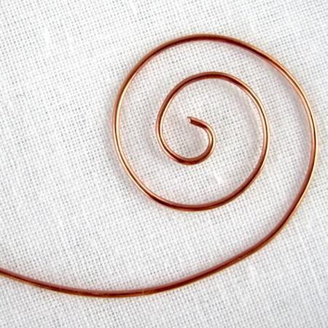
The curve makes relatively compact turns around its center.

6. Loose Spiral-Like Open Curve
# Source: AI Source: Provided by: [Data Path: Persons Table -> ID Column: 1, Name_En Column: Motasem Essam] -> From: [ChatGPT] on [7/25/2026]
The turns are widely spaced.
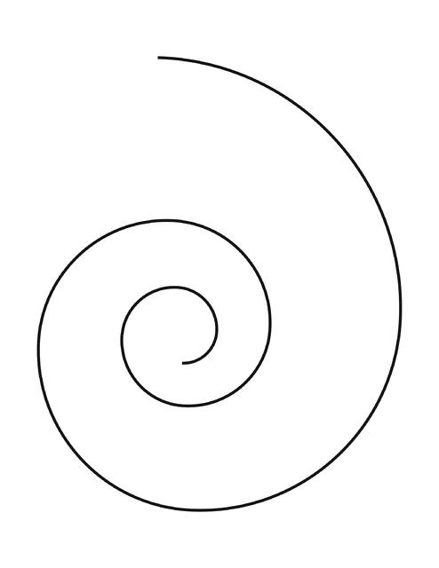
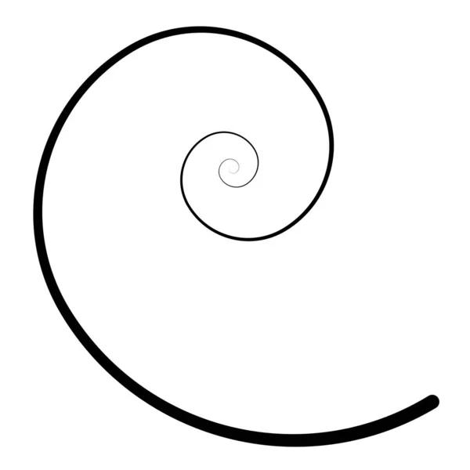
The curve expands more rapidly or has larger spacing between turns.

7. Symmetric Spiral-Like Open Curve
# Source: AI Source: Provided by: [Data Path: Persons Table -> ID Column: 1, Name_En Column: Motasem Essam] -> From: [ChatGPT] on [7/25/2026]
The spiral has a regular and consistent geometric pattern around its center.
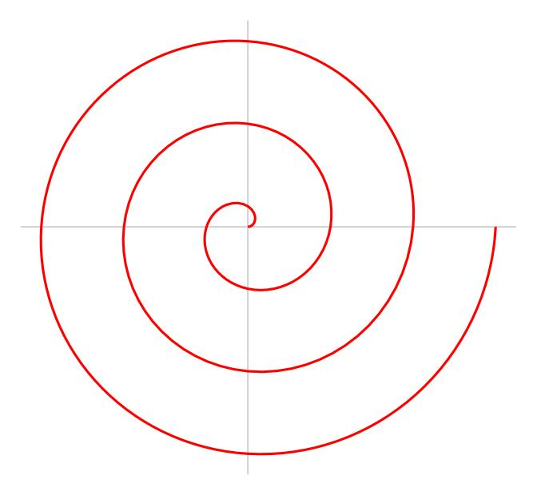
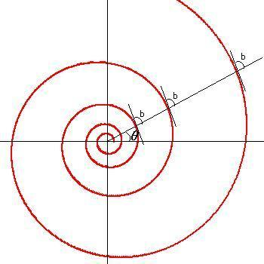
Its appearance remains relatively consistent as it winds around the center.

8. Asymmetric Spiral-Like Open Curve
# Source: AI Source: Provided by: [Data Path: Persons Table -> ID Column: 1, Name_En Column: Motasem Essam] -> From: [ChatGPT] on [7/25/2026]
The curve winds around a central region but has unequal spacing, irregular turns, or an uneven overall form.
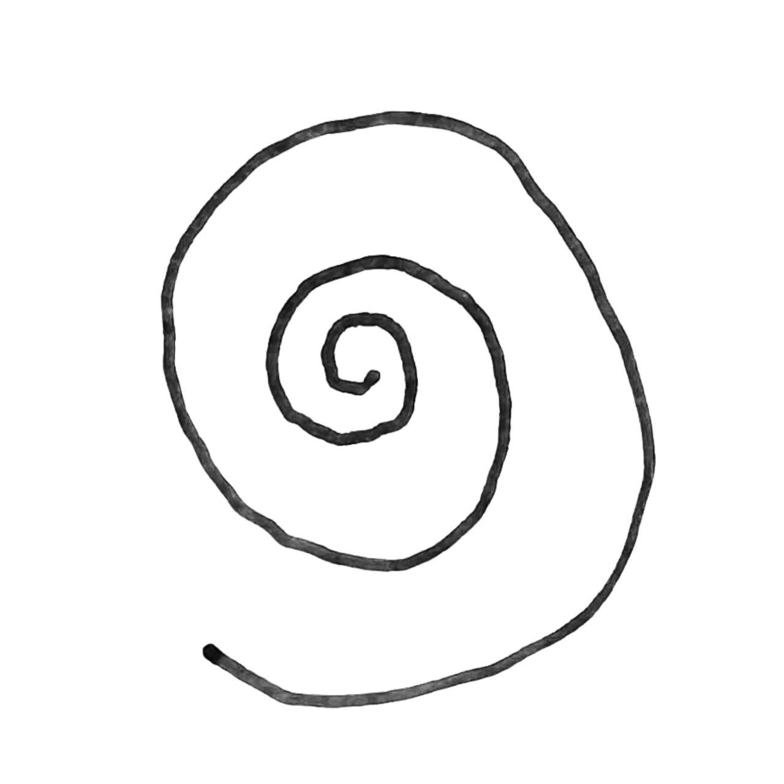
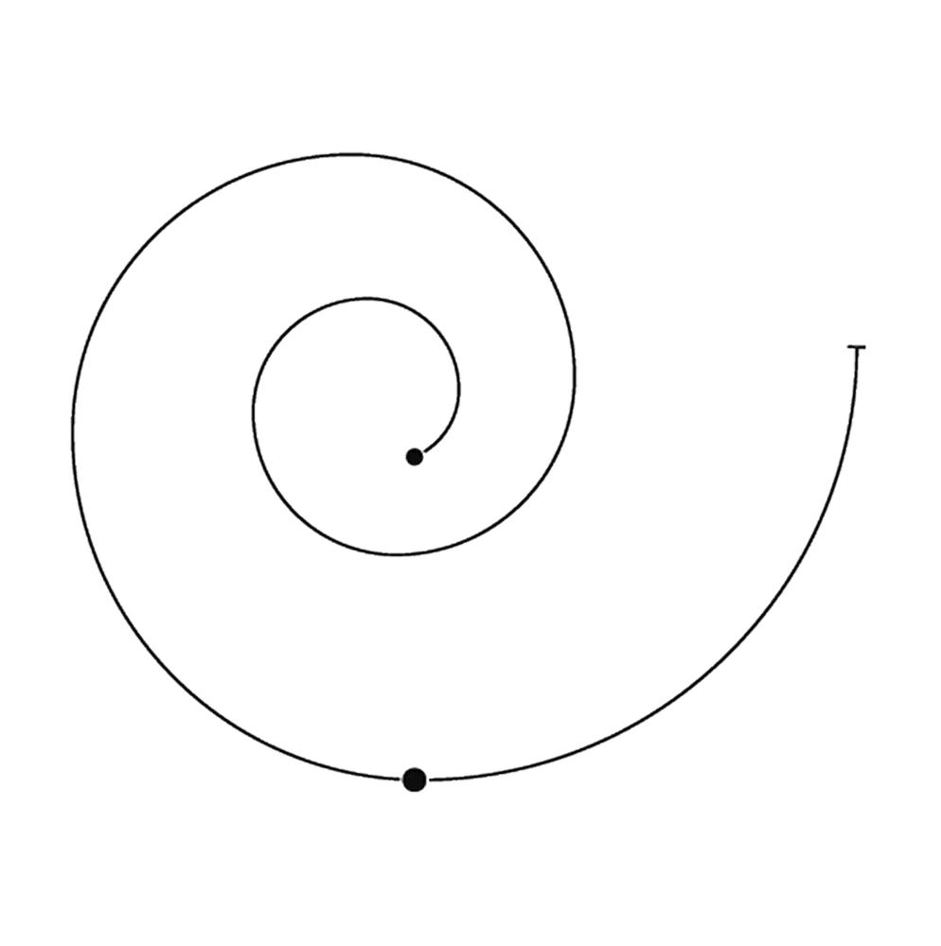
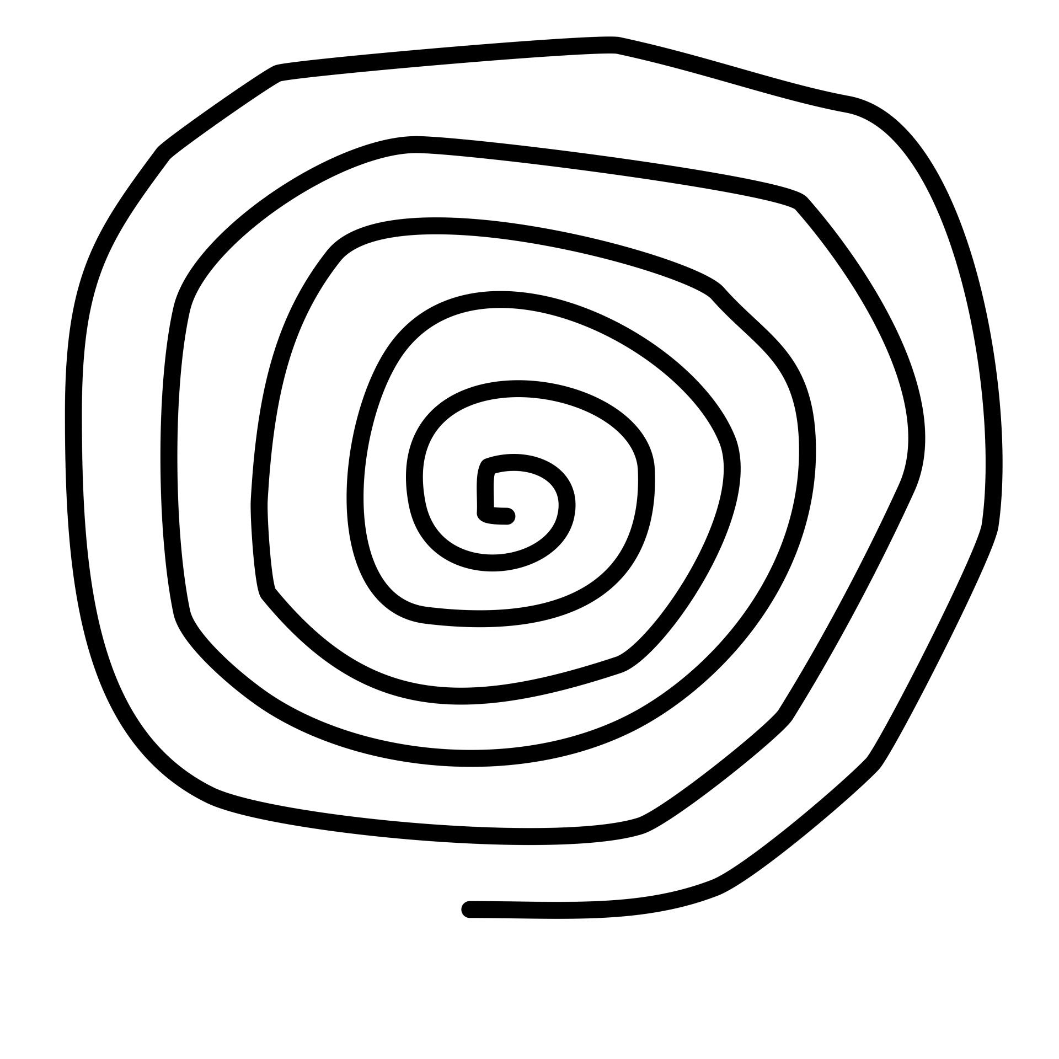
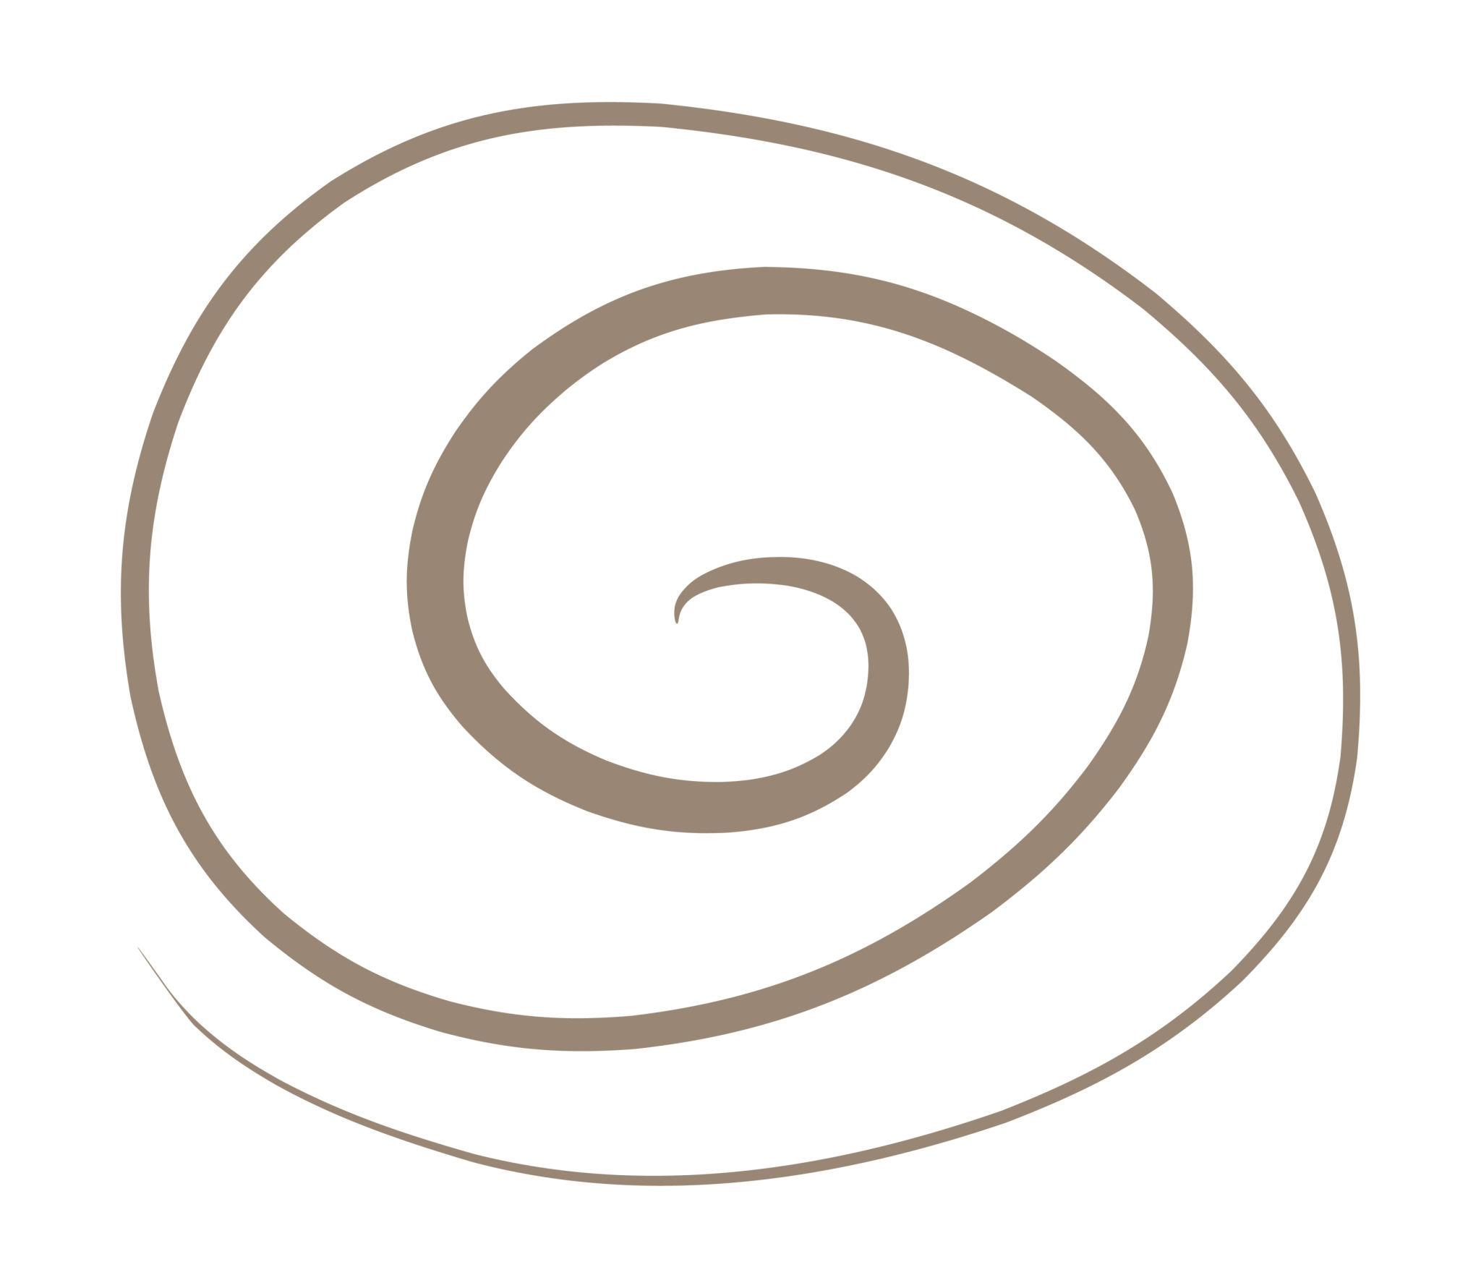
This type is especially useful for irregular and freeform shape classification.

9. Single-Turn Spiral-Like Open Curve
# Source: AI Source: Provided by: [Data Path: Persons Table -> ID Column: 1, Name_En Column: Motasem Essam] -> From: [ChatGPT] on [7/25/2026]
The curve makes approximately one complete turn around its central region.
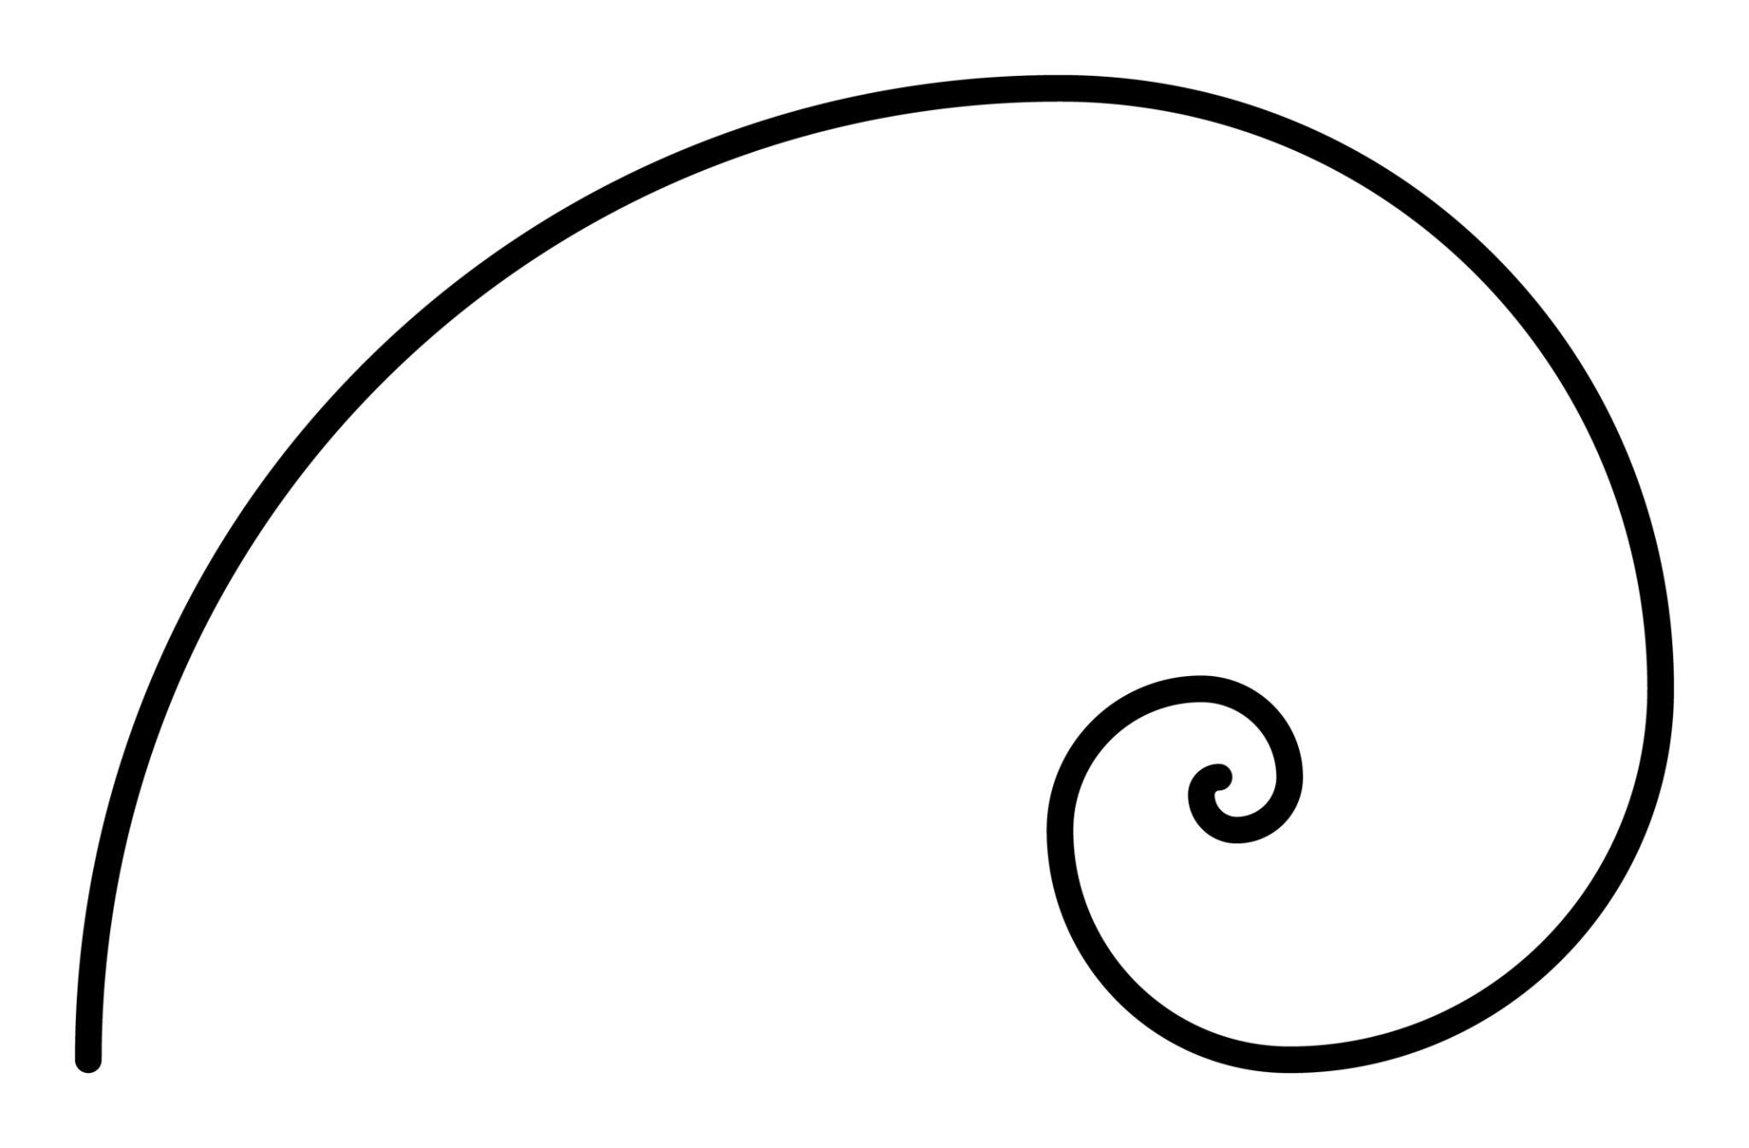
It remains open because the endpoints are not connected.

10. Multi-Turn Spiral-Like Open Curve
# Source: AI Source: Provided by: [Data Path: Persons Table -> ID Column: 1, Name_En Column: Motasem Essam] -> From: [ChatGPT] on [7/25/2026]
The curve makes several turns around its central region.
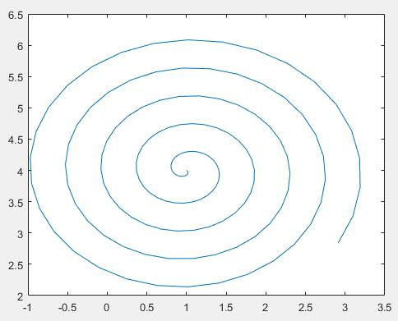
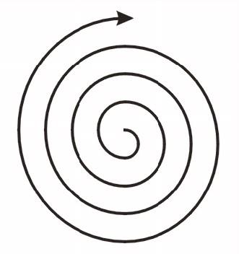
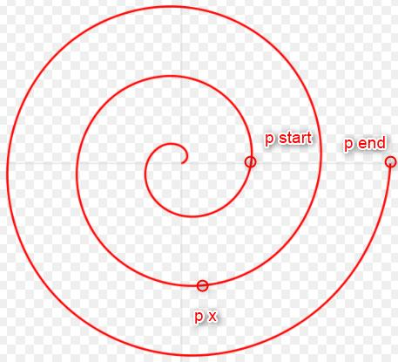
The number of turns can vary depending on the shape.

11. Organic Spiral-Like Open Curve
# Source: AI Source: Provided by: [Data Path: Persons Table -> ID Column: 1, Name_En Column: Motasem Essam] -> From: [ChatGPT] on [7/25/2026]
A naturally occurring or natural-looking spiral with irregular spacing and curvature.
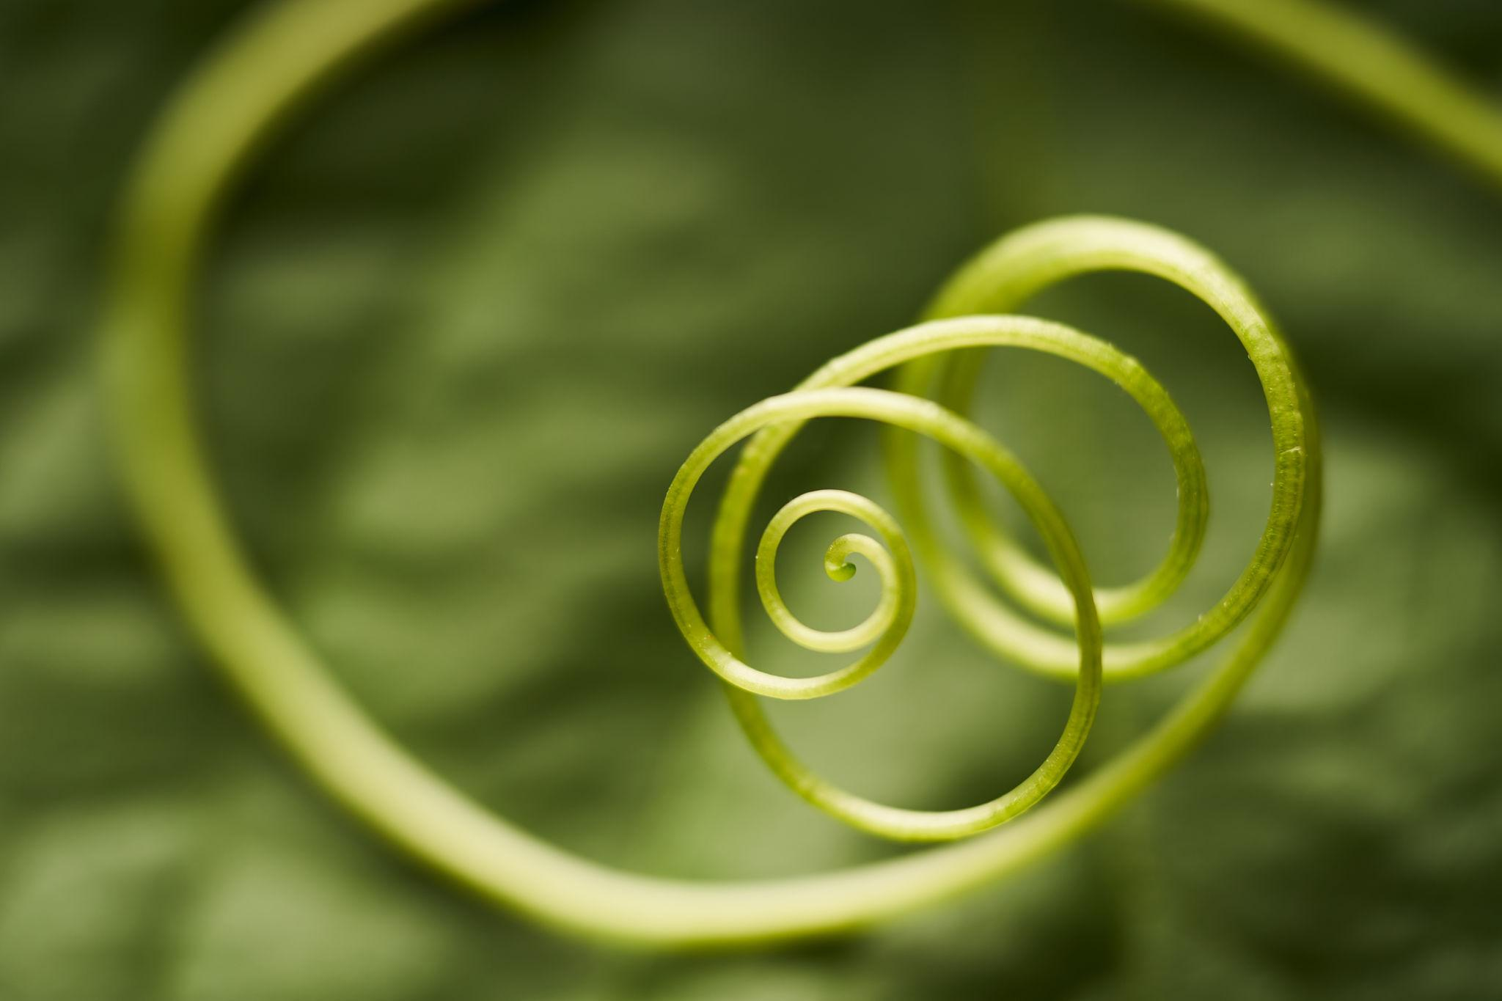
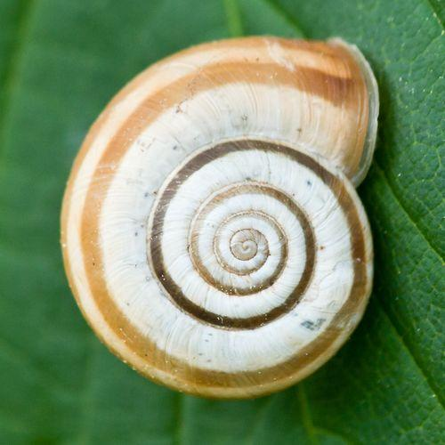
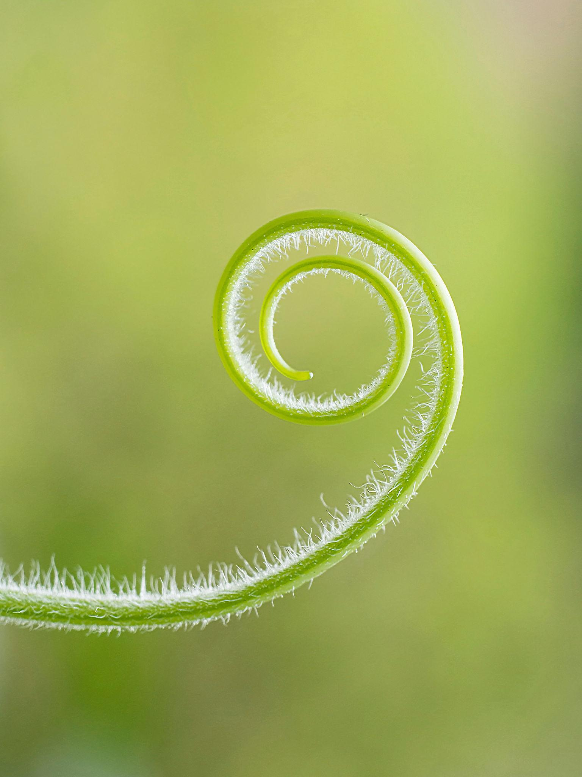
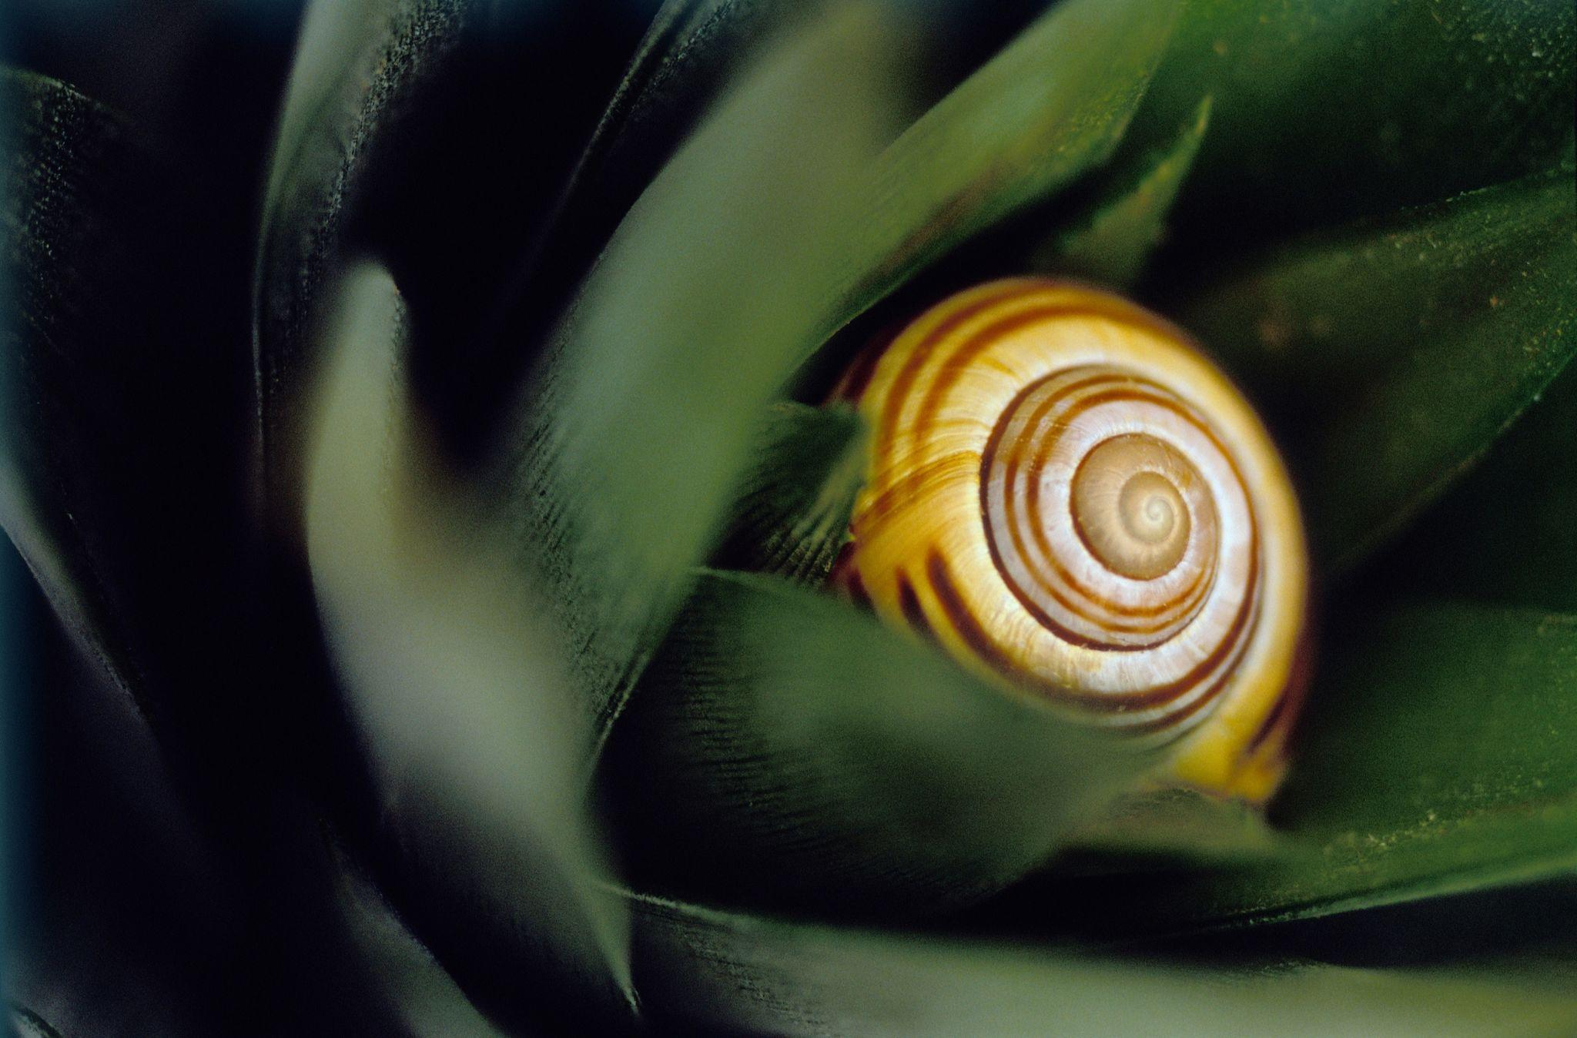
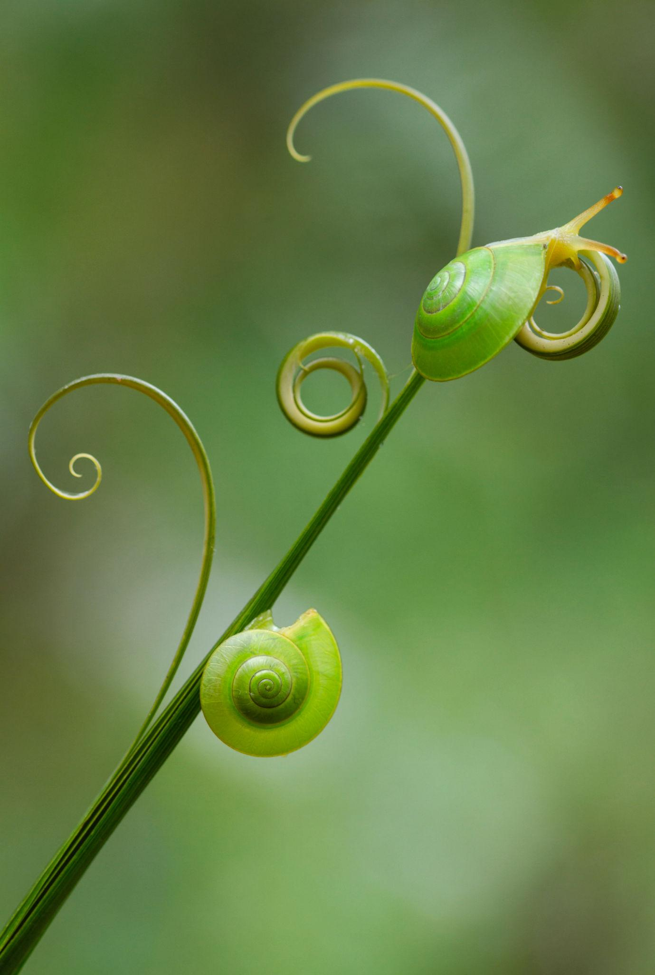
Examples include portions of plant tendrils, vines, and natural growth patterns.

12. Freeform Spiral-Like Open Curve
# Source: AI Source: Provided by: [Data Path: Persons Table -> ID Column: 1, Name_En Column: Motasem Essam] -> From: [ChatGPT] on [7/25/2026]
A deliberately designed spiral-like curve with freely controlled curvature and spacing.
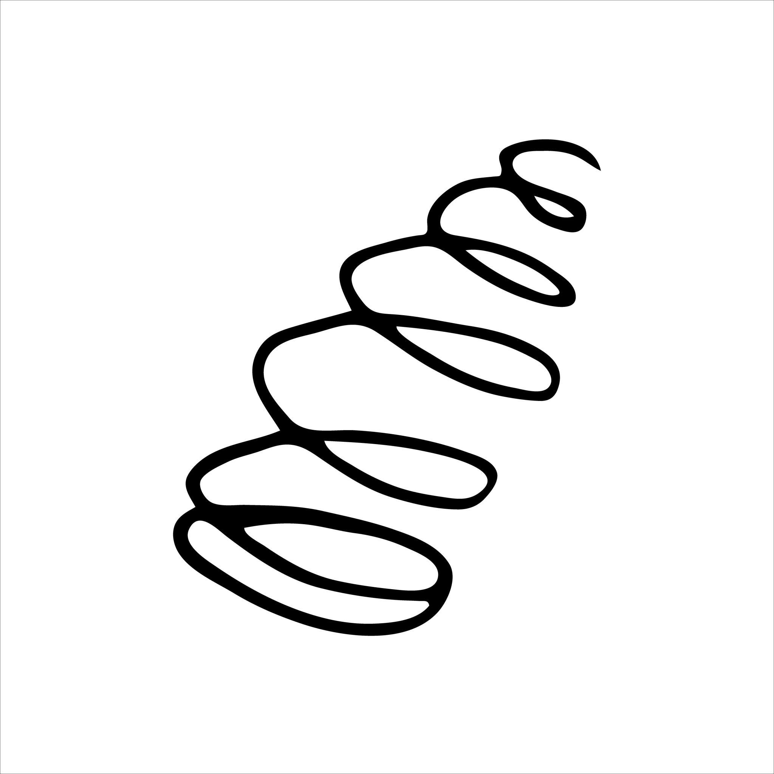
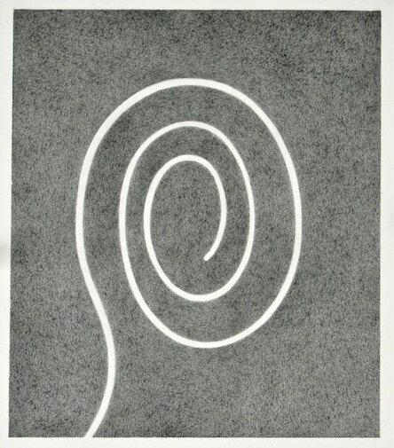
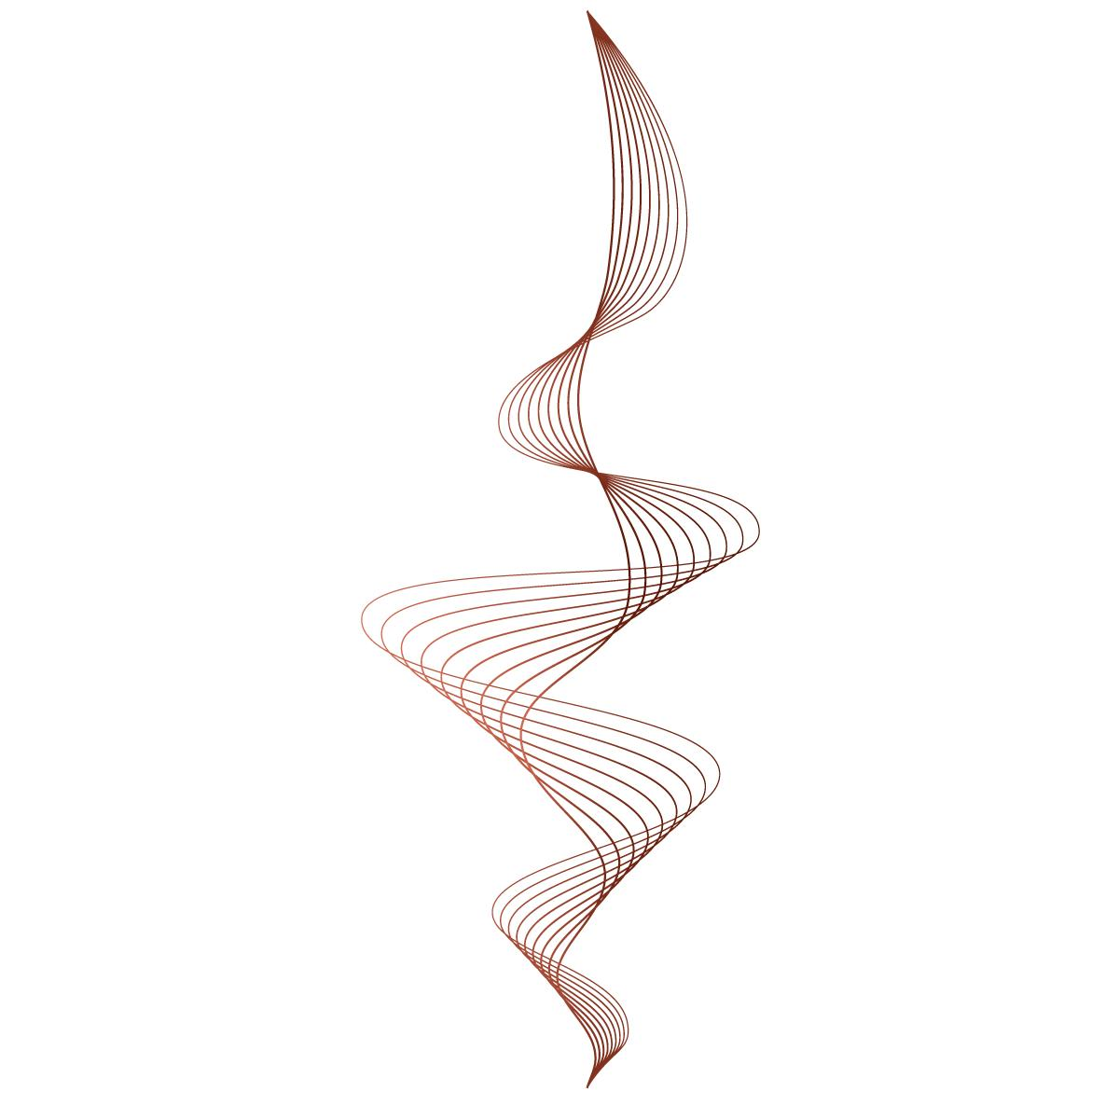

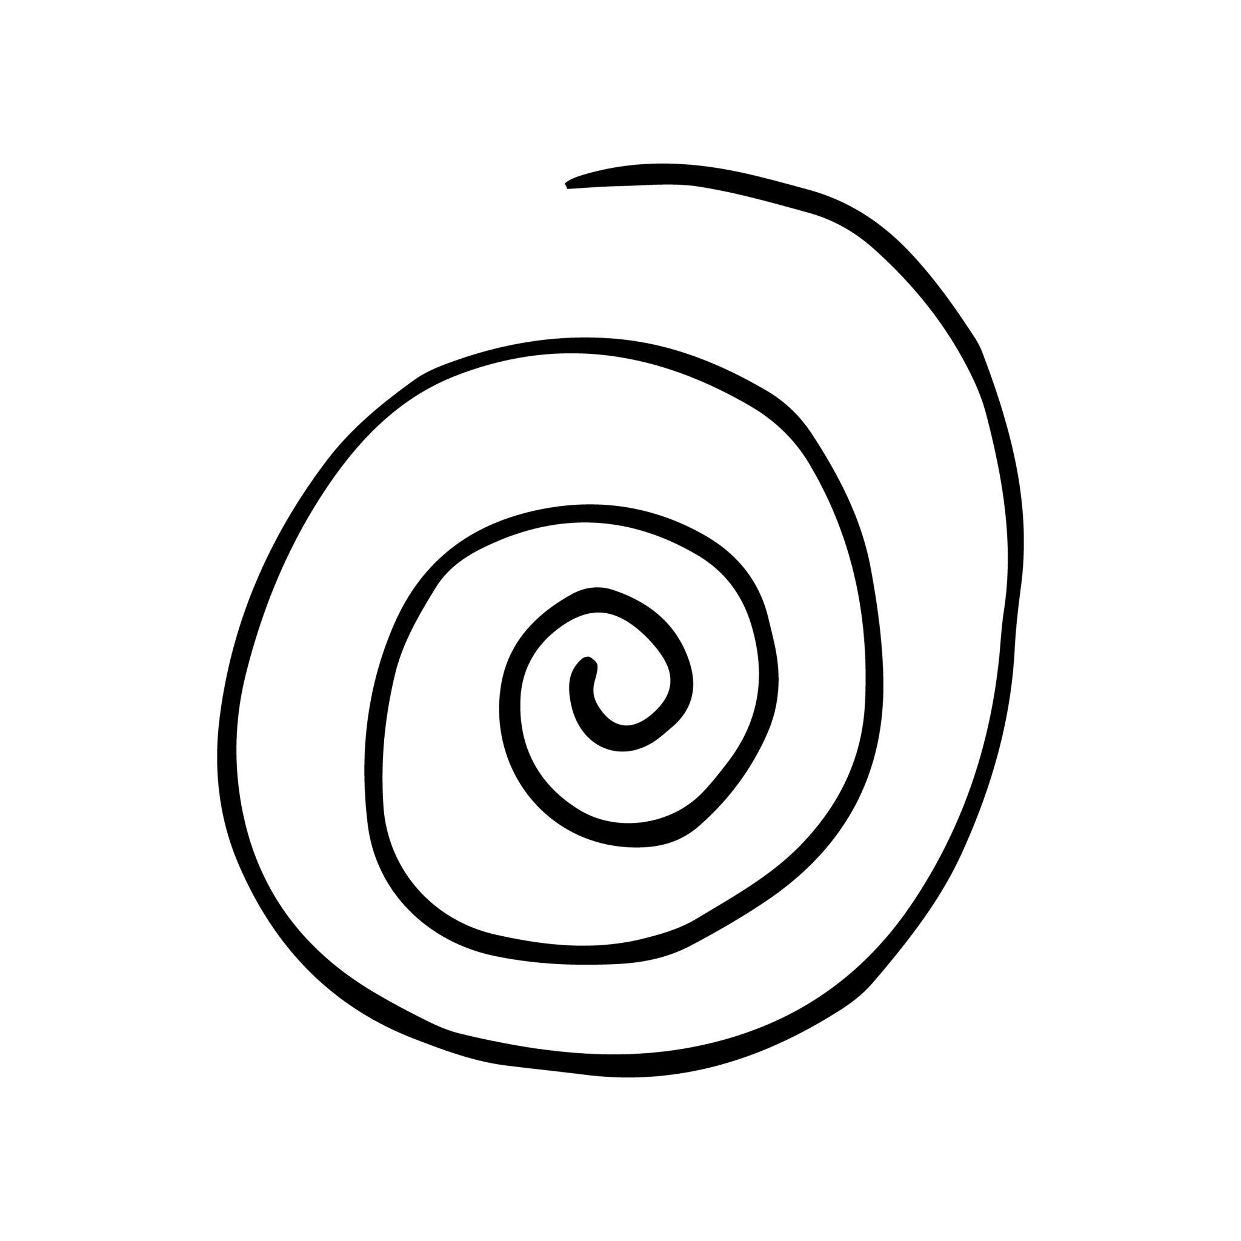
It does not necessarily follow a strict mathematical spiral equation.

Spiral-Like Open Curve vs. Wavy Open Curve
# Source: AI Source: Provided by: [Data Path: Persons Table -> ID Column: 1, Name_En Column: Motasem Essam] -> From: [ChatGPT] on [7/25/2026]
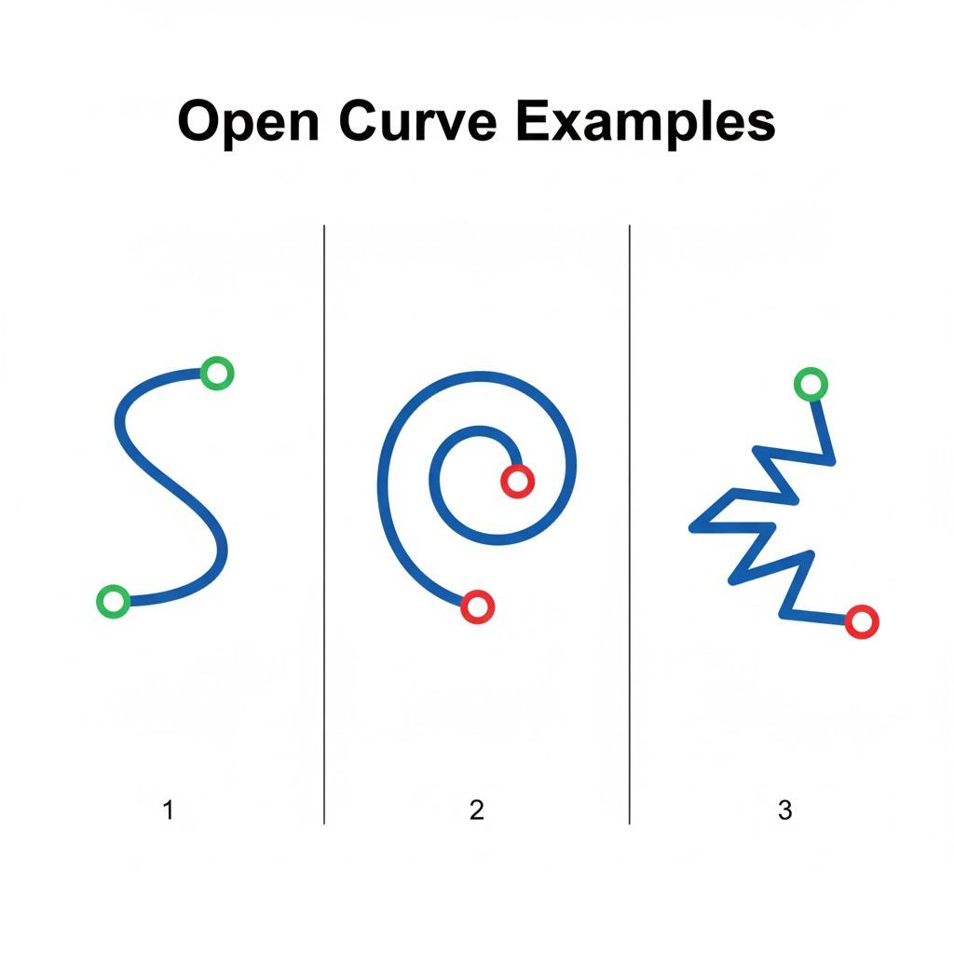
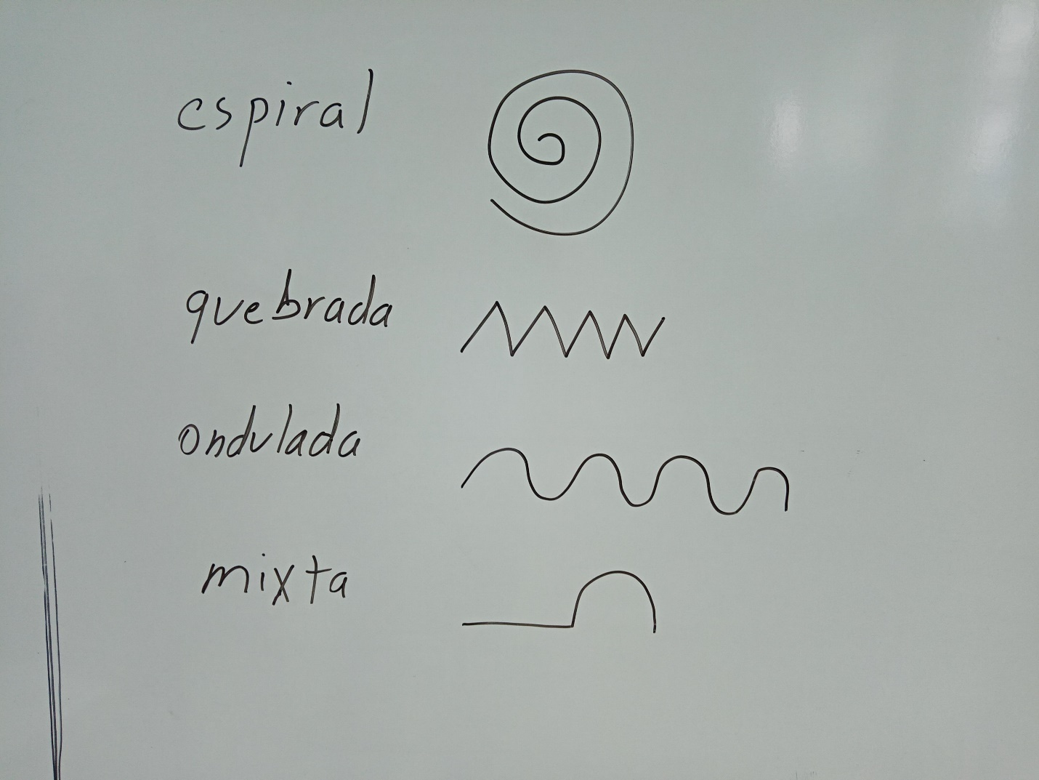
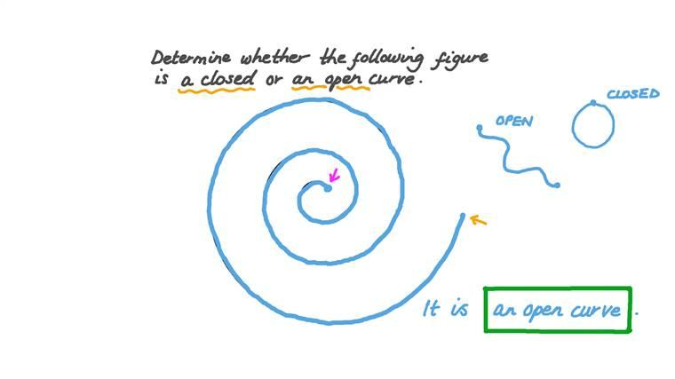
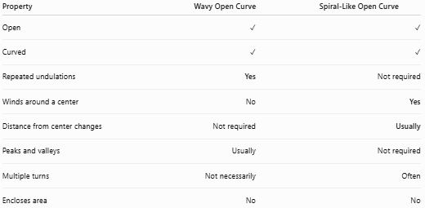
Property | Wavy Open Curve | Spiral-Like Open Curve
Open | ✓ | ✓
Curved | ✓ | ✓
Repeated undulations | Yes | Not required
Winds around a center | No | Yes
Distance from center changes | Not required | Usually
Peaks and valleys | Usually | Not required
Multiple turns | Not necessarily | Often
Encloses area | No | No
Main distinction
$$\boxed{\text{Wavy}=\text{Oscillates}}$$
while
$$\boxed{\text{Spiral-Like}=\text{Winds Around}}$$

Spiral-Like Open Curve vs. Circular Arc
# Source: AI Source: Provided by: [Data Path: Persons Table -> ID Column: 1, Name_En Column: Motasem Essam] -> From: [ChatGPT] on [7/25/2026]
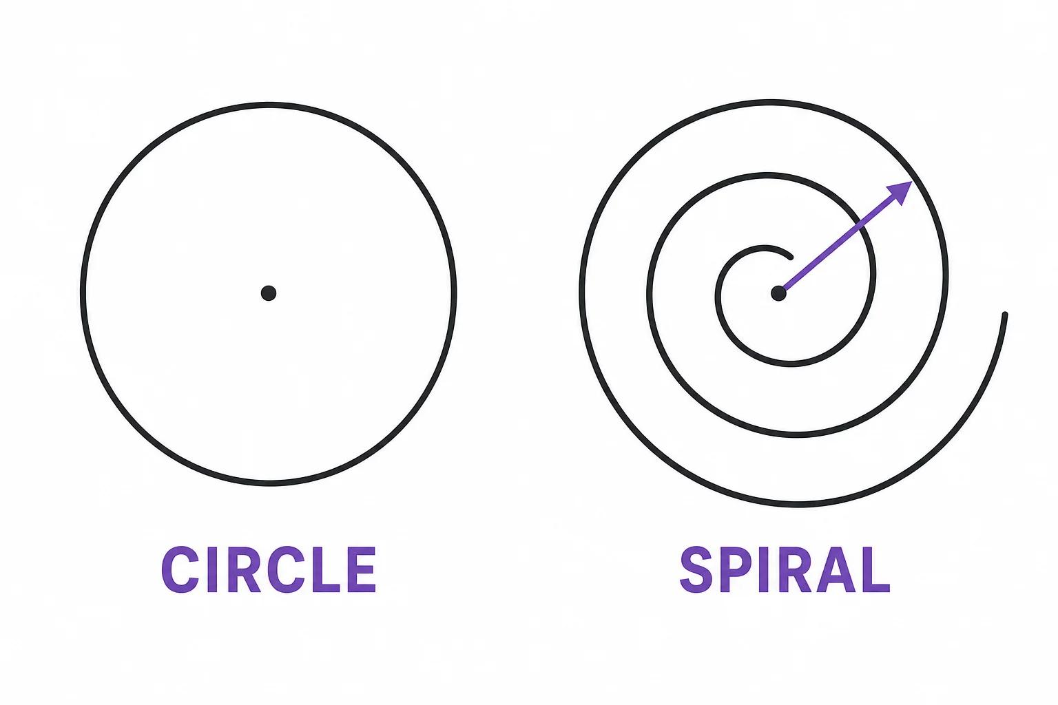
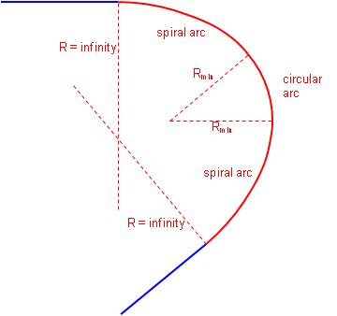
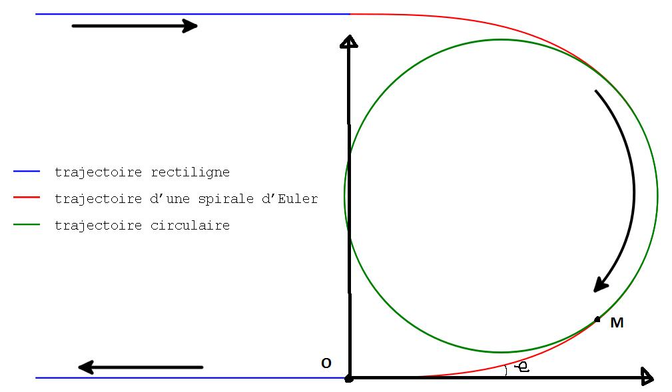
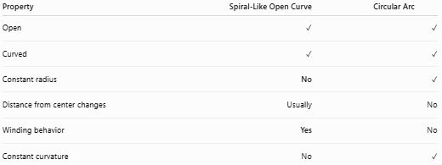
Property | Spiral-Like Open Curve | Circular Arc
Open | ✓ | ✓
Curved | ✓ | ✓
Constant radius | No | ✓
Distance from center changes | Usually | No
Winding behavior | Yes | No
Constant curvature | No | ✓

Key Points
# Source: AI Source: Provided by: [Data Path: Persons Table -> ID Column: 1, Name_En Column: Motasem Essam] -> From: [ChatGPT] on [7/25/2026]
A Spiral-Like Open Curve is:
$$\boxed{\text{Open}+\text{Curved}+\text{Winding}+\text{Changing Radial Distance}}$$
It:
- Has two endpoints.
- Does not close.
- Winds around a central point or region.
- Usually changes its distance from the center.
- Can wind inward or outward.
- Can have one or multiple turns.
- Can be tight or loose.
- Can be regular or irregular.
- Can be symmetric or asymmetric.
- Can be organic or freeform.

Conclusion
# Source: AI Source: Provided by: [Data Path: Persons Table -> ID Column: 1, Name_En Column: Motasem Essam] -> From: [ChatGPT] on [7/25/2026]
Spiral-Like Open Curves are open curved shapes distinguished by their winding behavior around a central region. They can be classified according to their mathematical form, direction of winding, spacing, number of turns, symmetry, and appearance. The key feature separating them from wavy curves is that a spiral-like curve progressively winds around a center, whereas a wavy curve primarily oscillates back and forth.

